 | UNIVERSITY OF WEST ATTICA  FACULTY OF ENGINEERING  DEPARTMENT OF ELECTRICAL AND ELECTRONIC ENGINEERING

An introduction to the Python programming language
with examples on Digital Signal Processing

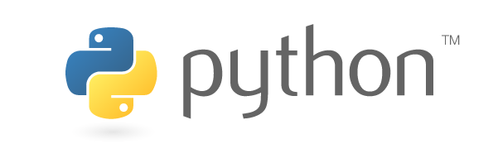

Student: Alexios Giazitzis
Registration Number: 503262017050

Supervisor

Elias N. Zois, Ph.D
Associate Professor

ATHENS-EGALEO,
version 1, November 2022

Licensed under the MIT License.
University of West Attica and Alexios Giazitzis,
November, 2022
Table of Contents
Introduction 5
1. Data Types – Operators 6
1.1. Data Types 6
1.1.1. Integer Numbers 7
1.1.2. Floating Point Numbers 7
1.1.3. String 7
1.2. Operators 8
1.3. Comparisons with MATLAB 12
2. Basic Functions 15
2.1. Printing 15
2.2. Acquiring input 15
2.3. Conversions 15
2.3.1. String to Integer or Float 16
2.3.2. Integer & Float to String 16
2.3.3. From decimal to common bases and vice versa 16
2.4. Comparisons with MATLAB 18
3. Flow Control Statements 19
3.1. Boolean Type & Values 19
3.2. Conditional Operators & Expressions 19
3.3. Simple, enhanced and multiple if branches 22
3.4. Loop Statements 25
3.4.1. While Loop 25
3.4.2. For Loop 26
3.4.2.1. Comparison with the common for loop construct of older languages 27
3.5. Comparisons with MATLAB 29
4. Lists 30
4.1. Declaration, List size and Multidimensional Lists 30
4.2. List assignment ways 32
4.3. List Methods & Functionality 33
4.3.1. Slicing & Clearing a list 33
4.3.2. Append, Insert, Extend, Remove & Pop 34
4.3.3. Sort & Reverse 35
4.3.4. Count & Index 36
4.4. Strings 36
4.5. The in operator: finding if an element is in a list 37
4.6. Comparisons with MATLAB 38
5. Functions 39
5.1. Built-in Functions 39
5.2. Creating Functions 43
5.3. Using created functions 44
5.4. Comparisons with MATLAB 45
6. File manipulation 47
6.1. Reading files 48
6.2. Writing files 49
6.3. `with` keyword 49
6.4. Comparisons with MATLAB 50
7. Modules 51
7.1. Importing and using built-in modules 51
7.1.1. math & cmath 51
7.1.2. array 54
7.1.3. csv 55
7.2. Third party modules 57
7.2.1. NumPy 58
7.2.2. matplotlib & Pillow 61
7.3. Comparisons with MATLAB 62
8. Examples & Exercises 63
8.1. Examples 63
8.2. Exercises 76
9. Advanced Topics 77
Appendix A: Installation 78
Windows 78
Linux 78
Mac 79
Verifying the installation 79
Appendix B: Python scripts, IDLE & Interactive Shell 81
Appendix C: Pip & Virtual Environments 83
References 85

Introduction
Interpreted languages differ from compiled languages in the sense that they don't need a compiler to translate them to machine code in order to be executed, instead an interpreter program executes the written code line by line. Although that increases productivity, implementation and testing times, interpreted languages lose performance when compared to compiled languages due to the intermediate step before the code is run as machine code, whereas compiled languages need more time before testing due to the compilation time but run faster.
Python is one such language [1]. It's an interpreted language that applies the Object Oriented Paradigm (abbreviated as OOP) and excels at automation, data science, machine learning, AI development and many other fields. Although interpreted, Python has a fast implementation which makes users unable to notice the performance loss without using monitoring tools and comparing the measurements to a compiled language's code.
This document presents the basic knowledge required to get into Python and use it for simple programs. Besides the code examples shown in each chapter, more examples are included in the distribution file of this document which are based on Digital Signal Processing concepts. These may utilize more features of the language than what are presented, properly commented, for anyone willing to go a step further. Alongside these, each chapter will contain a part that compares the Python language to the MATLAB language, which is widely used in the academic communities, especially in engineering departments, for learning purposes.
For installation guidance, the interested reader may take a look at Appendix A: Installation. Note, that this document was written using Python 3.9, future versions may have differences which could make the information given obsolete.
For any mistake that is spotted in this document, create a new issue in the GitHub page of the project.

Data Types – Operators
The first step into programming with Python and creating complex programs is getting to know the type of data that can be used with it and how they can be stored and processed by the program code. Python uses the concept of variables to store data.
Variables are words of any length, defined by the user, that hold values of any kind. In Python, there are some limitations when it comes to naming them [2]:
- Variable names can only contain alphanumeric characters and underscores (a-z, A-Z, 0-9 and _)
- Variable names CANNOT start with a number and MUST start with a letter or underscore
- Variable names are case-sensitive, which means var, Var and VAR are three different variables.

Unlike other languages, Python’s variables are not normally declared, they are just defined (assigned). Declaration refers to specifying an identifiers’ (variable name) properties, like it’s type, while assignment refers to making an identifier store a specific value. Undefined variables can not be used. Variables in Python are assigned. in a very simple manner [3]:
variable_name = assigned_value

Values are frequently referred to as literals [4] as well. In the snippet of Image 1.1, variables are seen being assigned a numerical value.
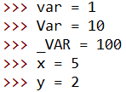Image 1.1: Variable assignment.
Moving forward, lines starting with the hash symbol, #, in the code examples, are considered a comment. Comment lines are skipped by the Python Interpreter and they help in documenting our code [5].

Data Types
Creating user friendly programs would be a tedious task if only numbers could be used when programming. Python allows the usage of a couple of more data types, which are a way to define the type of value a variable assumes, one of which was showcased in the snippet of Image 1.1, integer numbers [6].
As a note, Python, unlike other major languages like C, C++, Java, etc, is a dynamic typed language [1]. Thus, the type of the variable used isn't determined until the code is run, which in turn means that a variable can be a number at some point and then an alphanumeric sequence at a later time, which can produce issues if not careful with how and where they are used. An example of a malfunctioning code like that will be included in the supplementary example set due to it containing syntax that is explained on other chapters.

Integer Numbers
One of the most common data type is the well known integer, like 1, 25, 100, etc. They are a commonly used data type, due to the fact that many things in life are counted as a whole. Variables of the int type are declared as such:

variable_name = integer_value

An example of which, can be seen in Image 1.1.

Floating Point Numbers
Although integers are quite commonly used, they lack the ability to represent real numbers. As an example, for any transaction that involves money, if only integer values were used, one of the sides of this transaction would most probably lose money. In mathematics, decimal numbers are used, which provide increased precision on the result of operations. Similarly, Python offers us floating point literals [6]. These numbers are decimals, but with an unknown number of digits before and/or after the decimal point. This means that float variables can have a really big or small precision, based on the programmer’s needs and the hardware limitations. Floating point variable assignment is show in Image 1.2, which generally comply to the following form of writing:
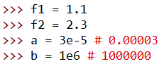Image 1.2: Float variable assignment.
variable_name = float_number

String
Writing a program that only displays numbers, whether integer or decimal, would not be user friendly since plain numbers do not represent anything without any informational text close to them. Luckily, Python allows the use of alphanumeric data [7], also know as the String data type, which can be declared in the following way:
variable_name = "string of your choice in here"

String literals are placed inside double quotation marks (single quotation marks can be used as well) so that they
can be interpreted as an alphanumeric sequence rather
than numbers or anything else.
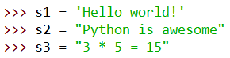Image 1.3: String variable assignment.

Operators
Having the ability to just associate values with variables although useful, is quite poor if a program can’t perform basic programming operations on them, like addition, subtraction, string concatenation, etc. In Python, such functionality can be carried out with the use of operators, which take one or two values and/or variables, known as unary and binary operator types respectfully in order to produce a single result. Therefore, operators are used to write expressions. Expression is a line of code that evaluates to some value [8]. In the tables below, some basic operators, their name, type, meaning and examples are provided [9].

- Value Operators [10]
Operator | Name | Type | Description | Examples
+ | Unary plus | Unary | Positive value operator.  Doesn’t change the value/variable. | - +1  - +2.5  - +3e-9
- | Unary minus | Unary | Negates the value/variable. | - -1.7  - -x  - -8e5

- Arithmetic Operators [10]
Operator | Name | Type | Description | Examples
+ | Addition | Binary | Sum of the two operands if they are numbers.  Concatenation of the two operands if they are Strings. | - 1 + 2  - 3.7 + x  - “Stri” + “ng”
– | Subtraction | Binary | Difference of the two operands. | - 10 – 99  - x – 9.3  - z – y
* | Multiplication | Binary | Product of the two operands. | - 3 * 5  - x * 10  - y * z
/ | Division | Binary | Quotient of the two operands. | - 1 / 2  - x / 3  - b / a
// | Integer Division | Binary | Floored quotient of the two operands. | - 2 // 3  - 5 // z  - x // y
% | Modulus | Binary | Remainder of the integer division of the two operands. | - 3 % 5  - x % 9  - a % b
** | Exponentiation | Binary | First operand to the power of the second operand. | - 3 ** 2  - 10 ** x  - z ** b

- Bitwise Operators [11]
Operator | Name | Type | Description | Examples
& | AND | Binary | The result of the operation contains bits set to 1 in the positions where on both operands the bit is 1, with the rest of the positions containing 0. | - 2 & 1 # = 0  - 10 & 2 # = 2  - 255 & 128 # = 128
| | OR | Binary | The result contains bits set to 1 in the positions where any of the operands bits in the same position are 1, anything else being set to 0. | - 10 | 1 # = 11  - 128 | 64 # = 192  - 6 | 1 # = 7
^ | XOR | Binary | The result contains bits set to 1 in the positions where only one of the two operands bit is set to 1. | - 3 ^ 4 # = 7  - 1 ^ 1 # = 0  - 10 ^ 7 # = 13
~ | NOT | Unary | Inverts all the bits. | - ~1 # = - 2  - ~100 # = -101  - ~9999 # = -10000
<<  >> | Left/Right  bit shift | Binary | First operand shifted left/right by an amount of bits equal to the second operand. | - 100 >> 3 # = 12  - 128 << 1 # = 256  - 2048 >> 10 # 2

Bitwise operators require numerical operands, as they affect the internal bit representation of them.

- Augmented Assignment Operators [12]
Operator | Name | Type | Description | Example
+= | Incremented assignment | Binary | Sum the two operands then assign the result to the first | x += 2 # x = x + 2
–= | Decremented assignment | Binary | Subtract the two operands then assign the result to the first | x –= 2 # x = x – 2
*= | Multiplied assignment | Binary | Multiply the two operands then assign the result to the first | x *= 2 # x = x * 2
/= | Divided assignment | Binary | Divide the two operands then assign the result to the first | x /= 2 # x = x / 2
//= | Integer divided assignment | Binary | Perform an integer division on the two operands then assign the result to the first | x //= 2 # x = x // 2
%= | Modulus assignment | Binary | Find the modulo of the two operands then assign it to the first | x %= 2 # x = x % 2
**= | Exponentiation assignment | Binary | Raise the first operand to the power of the second operand then assign the result to the first | x **= 2 # x = x ** 2
&= | AND assignment | Binary | Perform an AND operation with both operands then assign the result to the first | x &= 2 # x = x & 2
|= | OR assignment | Binary | Perform an OR operation with both operands then assign the result to the first | x |= 2 # x = x | 2
^= | XOR assignment | Binary | Perform a XOR operation with both operands then assign the result to the first | x ^= 2 # x = x ^ 2
<<=  >>= | Bit shift assignment | Binary | Perform a bit shift, left or right, operation with both operands then assign the result to the first | x <<= 2 # x = x << 2  x >>= 2 # x = x >> 2

Although these are not all the operators Python offers, the rest will be shown once certain topics have been covered.

Comparisons with MATLAB
MATLAB contains data types that cover a big variety of ranges, unlike Python. This does introduce issues like having to know and remember which type of integer is used for which variable and so on, but allows for better memory optimization and proper value limitation where needed. The following basic data types are available in MATLAB [13], [14], [15]:

double | Double-precision decimal numbers, 64 bits, IEEE Standard 754 for double precision.
single | Single-precision decimal numbers, 32 bits, IEEE Standard 754 for single precision.
int8 | 8-bit signed integer numbers, -128 to 127.
int16 | 16-bit signed integer numbers, -32,768 to 32,767.
int32 | 32-bit signed integer numbers,  -2,147,483,648 to 2,147,483,647.
int64 | 64-bit signed integer numbers,  -9,223,372,036,854,775,808 to 9,223,372,036,854,775,807.
uint8 | 8-bit unsigned integer numbers,  0 to 256.
uint16 | 16-bit unsigned integer numbers,  0 to 65,536.
uint32 | 32-bit unsigned integer numbers,  0 to 4,294,967,296.
uint64 | 64-bit unsigned integer numbers,  0 to 18,446,744,073,709,551,616.
string | Alphanumeric sequence.
char | Single alphanumeric symbol.

MATLAB’s operators are similar to Python's, with the exception that there are no augmented assignment operators. There are some special operators though that allow for element-wise operations, since all variables in MATLAB are handled like matrices. In the tables below, the most common operators are shown [16]:
Unary operators:
+ | Unary plus | Same as Python’s.
- | Unary minus | Same as Python’s.

Binary operators:
+ | Addition. | Same as Python’s.
- | Subtraction. | Same as Python’s.
.* | Element-wise multiplication. | Same as Python’s, but operates on elements in the same position of each matrix.
* | Matrix multiplication. | Matrix multiplication as known from linear algebra.
./ | Element-wise right division. | Same as Python’s, but operates on elements in the same position of each matrix.
/ | Matrix right division. | If A and B are matrices, then computes  [17]
.\ | Element-wise left division. | Same as Python’s, but operates on elements in the same position of each matrix.
\ | Matrix left division. | If A and B are matrices, then computes  [18]
.^ | Element-wise exponentiation. | Same as Python’s, but operates on elements in the same position of each matrix.
^ | Matrix exponentiation. | Multiplies a matrix by itself as many times as the right operand.

MATLAB contains functions for the modulo and bit-wise operations [19], [20], not operators. The basic ones are:
- mod(a, m) : performs the integer division of a by m and returns the remainder of it [19].
- bitand(A, B) : performs the bit-wise AND of A and B [21].
- bitor(A, B) : performs the bit-wise OR of A and B [22].
- bitxor(A, B) : performs the bit-wise XOR of A and B [23].
- bitcmp(A, B) : performs the bit-wise complement of A, similar to Python’s ~ operator [24].
- bitshift(A, k) : shifts the bits of A by k positions [25].
Although functions will be covered later, a quick explanation of what they are would be that they are easily callable pieces of code.

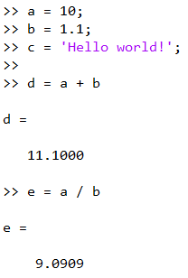Image 1.4: MATLAB variable declaration and operator usage.
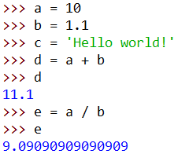Image 1.5: Python equivalent code of Image 1.4.

MATLAB shows the output of an expression whether or not it is used in an assignment statement. If a programmer wants to suppress that output, they can end each code line with a semi-colon `;`.

Basic Functions
Besides declaring variables, manipulating and saving data to them, Python offers to the programmer ways for their program to interact with the user. In this chapter, basic ways of showing messages to the user, getting input from them and showing numeric data in a different format are being explored.

Printing
Displaying messages in the users screen is frequently referred to as printing. In Python, the most common way, is by typing the function print() and writing values/variables to be printed inside it’s parenthesis, like the example of Image 2.1. It is by far the simplest way to display something on a screen,
as other would require either creating a custom User Interface (UI) or accessing the underlying system’s standard output mechanism.
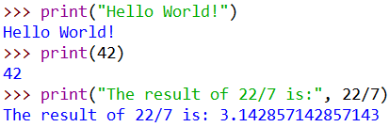Image 2.1: Using the print() function.
The print() function can take one, two or multiple arguments, separated by a comma, and it will print them on the user’s screen, separating them automatically with a whitespace character [26].

Acquiring input
Getting data entered to the program from the user, is generally
referred to as getting input. In a similar manner to print(), invoking the input() function, will enable the user to write anything in the console
and once the 'Enter' key is pressed, whatever written will be returned by the input() function as a String literal [27].
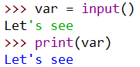Image 2.2: Using the input() function.
As shown in the example of Image 2.2, the returned value must be assigned to a variable in order to access it or manipulate it.

Conversions
Although, with the input() function, a user can enter anything in the terminal, Python returns it as a String. This can be a problem if the user’s input is a number which is required to perform any mathematical operation. Luckily, there are functions which can solve that.

String to Integer or Float
If the returned value from the input() function is a String which contains just
integers or floats, in either of the ways
with which they can be written, using the
int() [28] or float() [29] function respectively, with the variable or String literal as a
parameter, can produce a usable int or
float variable.
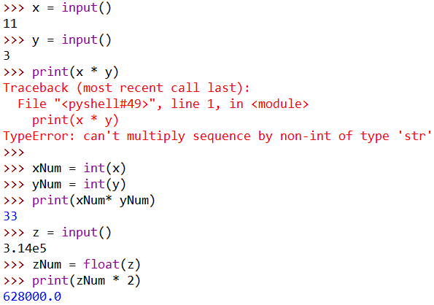Image 2.3: Conversion functions, from String to Int/Float.

Integer & Float to String
The opposite conversion from the previous one can be achieved as well. With the str() function, any number variable, int or float, can be turned into a String one [30]. Without it, concatenating an int or float to a string would not be possible.
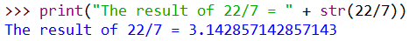Image 2.4: Converting a number to a String literal.

From decimal to common bases and vice versa
Although the decimal representation of integer numbers is useful and easy to read, sometimes it is needed that the same numbers are shown in a different format. In Computer Science, many integer numbers are represented in the binary or hexadecimal base fairly
often, due to the fact that computers and the science around those,
use these two formats for many aspects, like memory addresses,
MAC addresses, IP addresses, etc. In Python, we can convert from decimal to hexadecimal, octal and binary numbering systems using the functions hex(), oct() and bin() respectively.
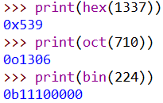Image 2.5: Decimal to most common bases.
Each format, uses a different prefix to differentiate one from the other, since they all share some common digits. Hexadecimal uses 0x [31], octal uses 0o [32] and binary uses 0b [33]. These functions return the numbers in the respective base numbering system as a String for us to manipulate however we like.
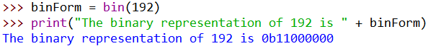Image 2.6: String variable of the bin() function output.

The opposite can be done as well. Using the prefixes mentioned earlier, variables with the decimal value of the number entered, in any of the three formats or convert a hex, bin or octal, can be created.
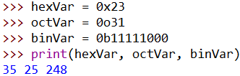Image 2.7: Creating integer variables using hex, oct or bin format.
If a number in different base system is given as a string, using the int() function with it and a second argument, called base, returns an integer in base-10 arithmetic whose value is equal to the initial number [28].

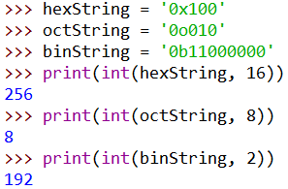Image 2.8: Converting string representations of numbers of different bases to integers.

Comparisons with MATLAB
MATLAB’s equivalent of Python’s print(value) is disp(value) [34] but does not accept multiple arguments like the former. If the programmer wants to print multiple variables and values at once, they need to combine them in a matrix whilst also making sure the there are not different types. The input(promptString) function exists in MATLAB [35] as well but does work differently. Unlike Python’s, it can evaluate expressions and return them in proper form, but they do have to be written properly like in Image 2.9. Giving the ‘s’ value a second parameter can make it behave like Python’s input(). Converting Strings to number variables can be done with str2num(value) [36] while the opposite with num2str(value) [37], the former having no way of differentiating between integers or doubles. If certain a matrix contains purely integer values, using the type of integer as a function can convert a double to an integer, thus extending the capabilities of str2num(value). Lastly, converting numbers from decimal to hexadecimal or binary can be achieved with dec2hex(value) [38] and dec2bin(value) [39], while the opposite with hex2dec(value) [40] and bin2dec(value) [41]. Conversing to octal base system can be accomplished with the built-in dec2base(value, 8) [42] while oct2dec(value) does the opposite [43].

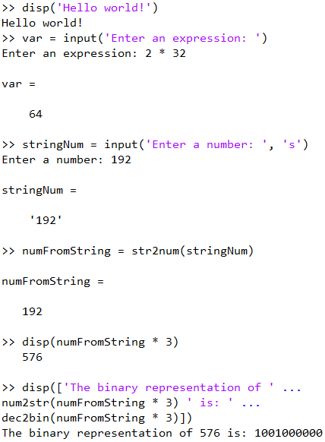Image 2.9: MATLAB code utilizing conversion functions.
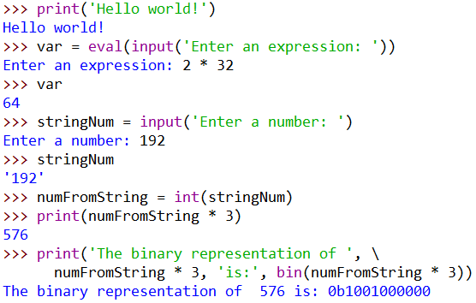Image 2.10: Python equivalent code of Image 2.9.

Flow Control Statements
In real life, programs are rarely coded in a linear and structured way. And since software are developed to solve problems, programming languages have to provide tools to programmers that allow them to control the flow of the program’s execution.

Boolean Type & Values
In order, for programming languages, to be able to provide conditionality they would have to map the two possible results to a value. Some languages specify the number 0 as the value of conditions that are not met, which means they are false, and any other number for conditions that are met, which means they are true. Other languages, like Python, offer a data type called Boolean (also known as bool), which can only exist as one of two values, True or False [44].
Boolean variables can be instantiated like all others, with the difference being that the right hand operand must be the value True or the value False. These two are case sensitive, so
they must be written with their first letter being an uppercase. These are the values that Python evaluates to and what flow control statements will require.
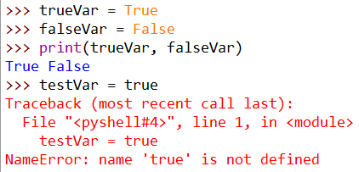Image 3.1: Boolean variable assignment.

Conditional Operators & Expressions
Using special operators, one can create expressions which evaluate to boolean values, hence making, simple or complex, conditions. The table below shows these operators along with their name, type, description and examples [45], [46].

Operator | Name | Type | Description | Examples
== | Equality Operator | Binary | Evaluates to True if left operand is the same as the right operand. False otherwise. | - 1 == 1 # True  - “Test” == “Testt” # False  - x == 2
!= | Inequality Operator | Binary | Evaluates to True if operands are not the same. False otherwise. | - 2 != 3 # True  - “Test” != “Test” # False  - y != 9
> | Greater than operator | Binary | Evaluates to True if the left operand is bigger than the right operand. False otherwise. | - 1 > 2 # False  - 2.9 > 3e-7 # True  - z > 128
< | Less than operator | Binary | Evaluates to True if the left operand is smaller than the right operand. False otherwise. | - 1 < 2 # True  - 0.001 < 0.01 # False  - var < 10
>=  <= | Greater than or equal to operator  Less than or equal to operator | Binary | Similar to their normal counterparts, with the difference being that these evaluate to True if left operand is greater than/less than or equal to the right operand. False otherwise. | - 1 <= 2 # True  - 3.14 >= 2  - x <= y
and | And operator | Binary | Evaluates to True of both operands are True. False otherwise. Multiple ones can be chained without any special care. | - True and False # False  - 1 >= 1e-10 and 2 < 10 # True  - x < 3 and x > -1 and x != 0

Operator | Name | Type | Description | Examples
or | Or operator | Binary | Evaluates to True if either of the operands evaluate to True. False otherwise. Multiple ones can be chained without any special care | - 1 < 2 or 3 > 4 # True  - 3 > 6 or 9 > 12 # False  - x > 3 or x < -1 or x > -4e10
not | Not operator | Unary | Negates the value right after it or the one inside the parenthesis. If parameter evaluates to True, returns False, and vice versa. | - not True # False  - not 3 <= 4  # False  - not (x != 1 and x > -3 and x < 10)

These operators can be used with both numerical and String variables/values, with which the comparison changes a little. Specifically with the greater/less than and greater/less than or
equal to operators, Strings are compared lexicographically [47].
This kind of comparison works in the following steps:
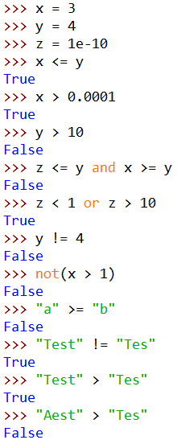Image 3.2: Comparing variables and values.
- All characters of the two strings are “turned” into their Unicode equivalent.
- Starting from the same position, characters are compared
to each other.
- If all characters from the left operand String are of
less/greater (than) Unicode value than the right’s, the condition evaluates to True/False accordingly. If even
one is not, the conditions evaluates in the opposite manner.
- String length is not taken into account unless one of the operands is the sub-String of the other and the right conditional operator is used.

Simple, enhanced and multiple if branches
One way to control the flow of a program, is by using statements that execute according to the Boolean output of a condition. These are called if statements [48], [49] and their syntax is provided as follows:
if condition:
if_condition_true_body_statement_1
...
if_condition_true_body_statement_n
statement_outside_if_body

When the condition evaluates to True, any statement below the if statement that is tab indented will be executed. It is important to note that all statements belonging in the same branch, must be indented, because if even one is not, it would mean that that statement and the others below it will execute regardless of what the condition evaluates to. An example of the important of indentation is shown in Image 3.4. The second print statement should have only been triggered if the number was indeed smaller than 10, but due to improper indentation, it triggered regardless.
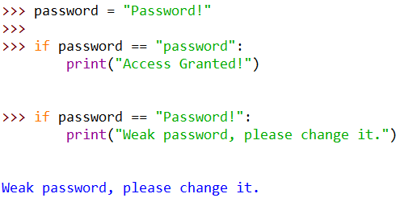Image 3.3: Using if statements
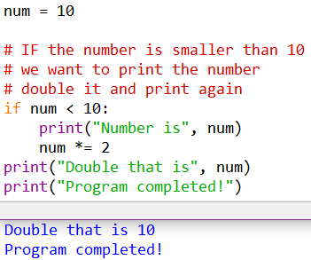Image 3.4: Importance of indentation.
Python allows the programmer to use the if / else statements, which execute the first set of statements if the condition evaluates to True, or the second set of statements if the condition evaluates to False. If / else statements [48], [49] are coded in the following way:
if condition:
if_condition_true_body_statement_1
...
if_condition_true_body_statement_n
else:
if_condition_false_body_statement_1
...
if_condition_false_body_statement_n
statement_outside_if_or_else_body

So a case of executing one branch or the
other based on a condition would look
like the example provided in Image 3.5. A simple statement like that can be written as single-liners, called conditional expressions [50] (also known as ternary expressions), as shown in Image 3.6. It is suggested to the interested reader to keep in mind that
conditional expressions work best when the
statements and expressions are small, else it
becomes less readable than the simple if / else statement.
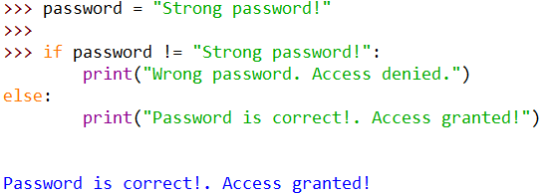Image 3.5: If / else statement. Only one code block is executed.

Image 3.6: If / else as a ternary expression, called conditional expression in Python.

Similar to other programming languages, Python offer the if / elif statement [48], [49], that allow having multiple branches in one if construct and is written as shown below.
if condition_1:
if_condition_1_true_body_statement_1
...
if_condition_1_true_body_statement_n
elif condition_2:
if_condition_2_true_body_statement_1
...
if_condition_2_true_body_statement_n
...
elif condition_n:
if_condition_n_true_body_statement_1
...
if_condition_n_true_body_statement_n
statement_outside_if_elif_bodies

If / elif gives the programmer the ability to become very
specific with what is executed when, while also being more efficient than chained ifs and if / elses, due to the fact that any
and all elif below an if are a part of it and so only the first condition of all that specified to True will execute code. Due
to this, it is important to place the conditions in an appropriate order based on their significance. If not placed correctly, it
would mean that the program will be executing actions in occasions when it should not and vice versa, like in Image 3.8.
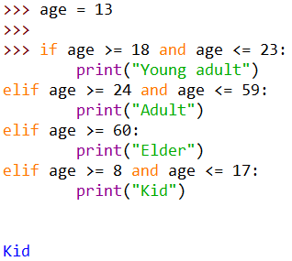Image 3.7: Using multiple elif statements to determine age category.

It is possible to use else as the finishing statement of an if / elif statement [48], [49], which is commonly used as a fallback code set execution if there is a need to execute actions if no condition is met.
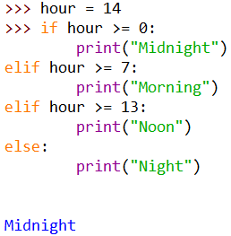Image 3.8: If/elif/else statement, disordered conditions

Loop Statements
Many times, it is required that programs execute a set of statements until a certain condition is met or for a specific amount of repetitions. With Python, a while loop statement is used for iterative execution until a condition is met [51], whilst a for loop statement is used to execute code a specific amount of times [52], [53].

While Loop
Many times, programmers
want a piece of code to be executed
an unknown number of times. This
can be achieved using a while loop statement, due to the fact that it
executes code in its body as long as
the condition specified evaluates to
True. It’s body are all statements
written below it that have at least
one level of indentation than
the while statement, similarly to the
if statement shown earlier. Once the
condition evaluates to False even once,
the while loop exits and the code
execution continues with the first
statement under it’s body. It’s syntax
is as follows:
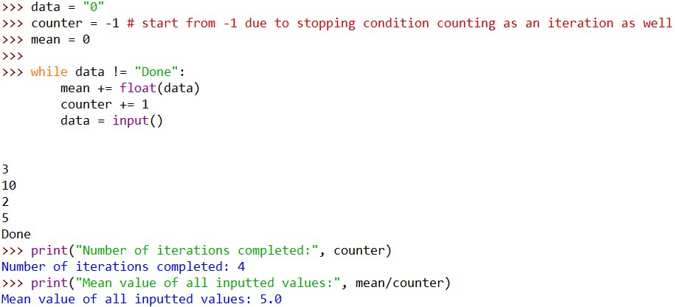Image 3.9: While loop statement finding the mean value of inputted values
while condition:
statement_in_while_body_1
….
statement_in_while_body_n
statement_outside_of_while_body

If for any reason there is a need to skip an iteration under certain conditions or exit the loop earlier, we can use the continue and break statements respectively inside a while loop inside an if statement.
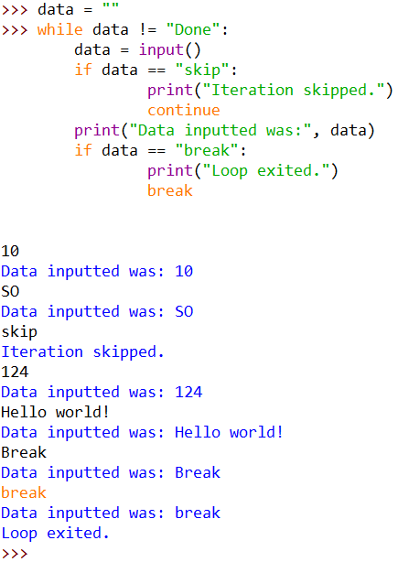Image 3.10: Continue & Break statements showcase.

For Loop
In order to execute code a predefined amount of times, Python offers the for loop statement. The syntax for it, is provided below.

for index_var_name in range(start, finish [, step]):
statement_in_for_body_1
...
statement_in_for_body_n
statement_not_in_for_body

A quick breakdown of the syntax is provided:
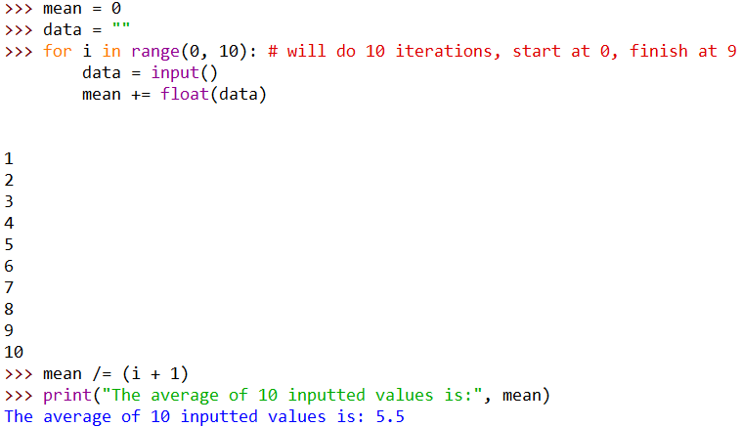Image 3.11: For loop running for 10 repetitions.
- index_var_name: can be any variable, even if it is not declared till that point, Python declares it for us
- start, finish: numerical
range for which the variable exists in,
start number inclusive, finish number exclusive. Must be of type integer.
- step: optional, specifying the increase
of the index_var_name on each repetition until index_var_name + step < finish evaluates to False. If not given by the programmer, it falls back to a default value of 1. Must be of type integer.
The in keyword requires an identifier as the left operand and an iterable sequence on the right, making the identifier assume each value of the sequence starting from the one on the first position ending with the one on the last. An iterable sequence refers to data types that hold multiple values, like a list, which is showcased in the next chapter. The range() function [54], [55] returns an iterable sequence based on the three parameters and is showcased in Chapter 5.1.
For loops always have a step, even if not provided, as explained above. That means that if the programmer requires a specific type of numeric sequence, using the range() function, it can be created. The only drawback is that the sequence has to be of integer type. Due to this, in order to have a numeric sequence that increases by a floating point step, one has to multiply the finish integer by a power of 10 equal to the decimal places the step contains, removing them in the process as well. The start integer may or may not be multiplied as well, based on what the starting number is wanted to be. Finally, inside the loop, the index would be divided by the same power of 10 used earlier in order to obtain the proper number. An example of this is provided in Image 3.12.

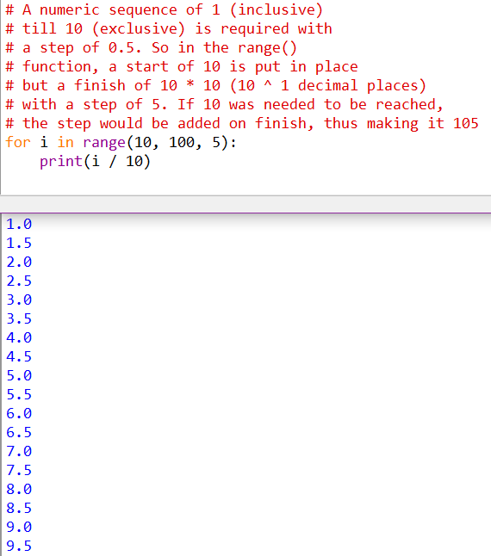Image 3.12: For loop with floating point step.

Comparison with the common for loop construct of older languages
For the interested reader that has experience with older or low level languages, the for loop construct of Python will seem quite different from the usual syntax. Specifically, in C, C++, Java, etc, the for loop syntax is:
for (instantiation_or_assignment; condition; step) {
for_body_statements
}

Although not directly shown, the underlying implementation of Python’s for loop syntax could be pictured of being similar to the syntax it in other languages, by just abstracting the condition part from having the user to write it. In detail, the index_variable takes a value from the right operand list of the in operator, as long as there are elements in said list, while the step is either given by creating a list-like object using the range() function or by having a predefined iterable sequence defined. As a supplement to this explanation, the flow chart of classic for constructs and Python’s implementation of it are provided in Image 3.13 and 3.14.
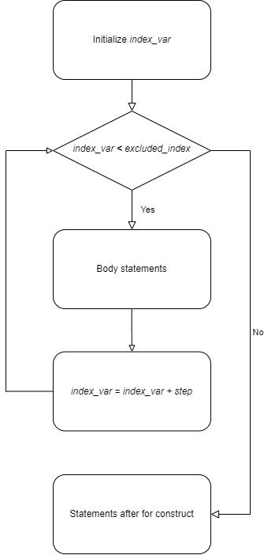Image 3.13: Flow chart of classic for loop.
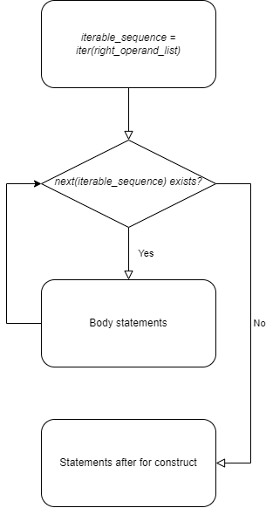Image 3.14: Flow chart of Python's for loop.

Comparisons with MATLAB
Rather than a Boolean Type, MATLAB contains the logical type, which is represented by 0 and 1 [56]. It contains the same conditional (known as relational and logical) operators, with the exception of how some are written [16], [57]. Specifically the not equal to operator is ~= while the operators and, or and not are written as &&, || and ~ respectively. MATLAB offers the and(), or() and not() functions, with the first ones operating on each element of two matrices, while the latter on one matrix, working similar to the respective operators but by comparing each index of the two matrices rather than the matrices as a whole. Lastly, the if [58], while [59] and for [60] statements are written as follows:
if expression  statements  elseif expression  statements  else  statements  end | while expression  statements  end | for index = startValue : endValue  statements  end

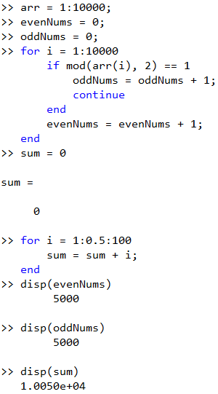Image 3.15: MATLAB code utilizing conditional and loop statements.
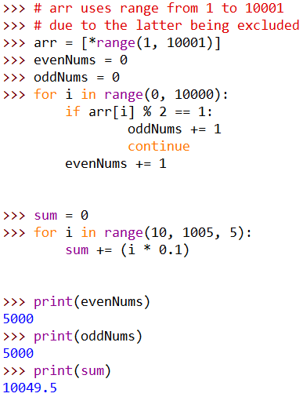Image 3.16: Python equivalent code of Image 3.15.

Lists
Storing data inside variables is a valuable asset to every programmer, as it allows them to reuse data at any point. Generally, it is quite rare for a program to only have a couple of variables or work with a small set of data that could be processed individually. Usually, data are processed in bulks, in the form of arrays, which are defined as structures that hold data in a specific order and/or in large quantities. In Python, such a data structure is called a list [61].
A list is a data structure that contains numbered positions, called indices, that hold data. Lists can contain all types of data, without being limited to one data type per list in Python. An important thing that must be remembered is that indexing starts from 0 and ends at
length_of_list – 1. Another important thing to remember is that the data in a list is ordered, meaning they retain the order in which they were put in, is modifiable, allowing both their content and length change, and may not be uniquely filled, meaning there may be duplicate values in it.
A list is not the same as an array from other languages. Arrays are data structures of a specific size that contain values of a specific type. Lists are data structures which can change in size at any point in time and may or may not contain values of different types. Which is why the concept of multidimensional arrays can not be directly implemented in Python, since it is not possible to always make sure the size of any dimension is consistently the same.

Declaration, List size and Multidimensional Lists
Empty lists are declared in the following way [62]:
var name = []
An empty list may be useful to fill with the results
of different set of expressions that our code contains. A
list with predefined data inside it can be assigned as shown below [62]:
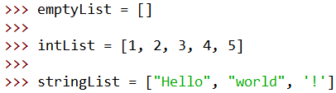Image 4.1: List assignment.

var_name = [data 1, data 2, data 3, …., data N]

In order to access the data in some position, the bracket
operators are used, which retrieve the value at the specified
index from the list, as long as the index is anywhere between
0 and the list_length – 1 [61], [55]:
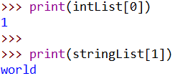Image 4.2: Accessing list elements.
list_name[index]
Image 4.2 shows an example of accessing elements of a list through indices. Specifically the second statement shows access to a String value of a list. It is possible to access a String’s character at a specific index and will be explained in a following chapter.
If an index outside of the specified range is given, an error would raised similar to Image 4.3.
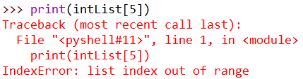Image 4.3: Accessing index out of the list's length.
In order to know the length of a list, at any point in time, it is best to use the len() function [61], [55], passing the list for which the length is needed as a parameter:
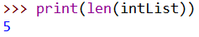Image 4.4: Using the len() function.
len(list name)

In most programming languages, using a for
loop and some way, whether it is a function or an internal variable of the list, of acquiring the length
of the list, is the way to access all the elements of it. Although the same can be done in Python, there is
a more effective way to iterate over a list, using an enhanced for loop (named as such in other languages), as shown in Image 4.6. Actually, all Python for loops are enhanced for loops as even the
function range() returns a list-like object [54], [55].
More about the range() function will be covered
in Chapter 5.1: Built-in Functions.
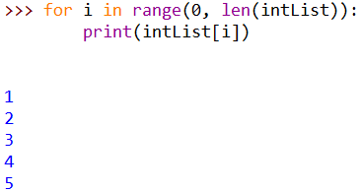Image 4.5: List access through a for loop.
In the code snippet provided in Image 4.6, the index variable elem was chosen arbitrarily; it can be any other variable name, similarly to normal for loops.
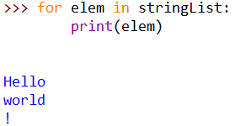Image 4.6: Enhanced for loop.
In accordance to multidimensional arrays, a possible way to do it is by having other lists of the same size nested inside another list. It would be up to the programmer to make sure
that the nested lists are always of the same size. An example
of multidimensional lists is provided in Image 4.7.
In order to access the value of a nested list, we use multiple brackets. Each one corresponds to the level of the list we are accessing. So the first one, corresponds to the top level list, the second one to the next level, and so on.
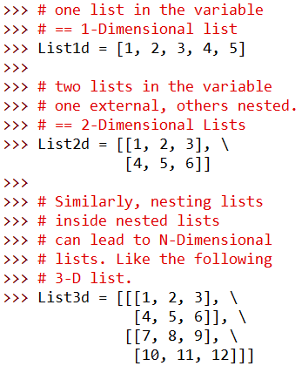Image 4.7: Multidimensional list assignment.
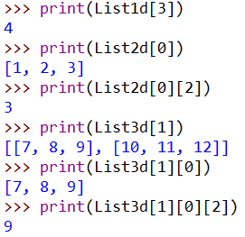Image 4.8: Accessing multidimensional lists.

List assignment ways
Sometimes, it is required to initialize a list with a predetermined size. For small amounts of data, this can be performed manually. But if it was needed to initialize a list filled with a hundred zeros, a programmer would lose valuable time writing it manually. Fortunately, the multiplication operator can be used to automate that process [55].
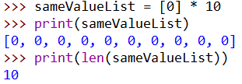Image 4.9: Assigning a list length of 10 with all elements being the same.
In the example of Image 4.9, a list of 10 items, all of which are 0, was instantiated. Similarly, a list with consecutive numbers may be needed. Using the range() function and the unpacking operator, a numerical sequence can be produced as a list. The unpacking operator `*` retrieves all the values of an iterable sequence, allowing them to be placed in another container. An iterable sequence is any data structure that contains multiple values which can be retrieved by the next() function. The next() function usage and how custom iterable sequences can be created, besides using lists, exceed the scope of this document. The syntax mentioned earlier, is referred to as a list display [63] containing a starred expression [64]. An example of this is provided in Image 4.10.

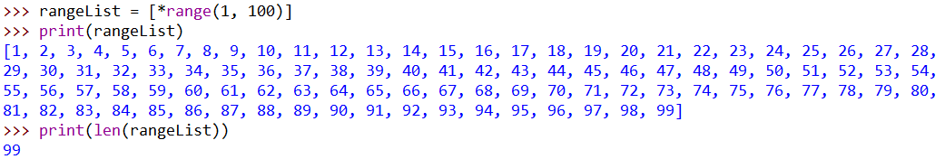Image 4.10: Using range() to initialize consecutive values.
It is not possible to use just the range() function to create a list with a numeric sequence as it’s return type is not a list, but rather a generic iterable sequence, which can be converted to a list either by using a starred expression in a list display or by wrapping the call inside the list() function [62], which takes a single parameter of an iterable type and returns it’s contents in a list.

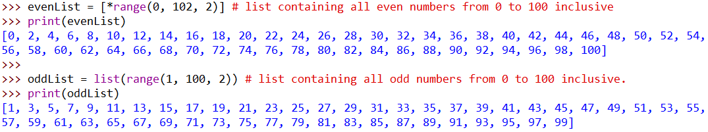Image 4.11: Creating number sequences with range().

List Methods & Functionality
Lists are a useful data structure, especially for larger programs where it is needed to store multiple information about something specific, like temperature for example. Many times though, it is required that the data is copied, modified, sorted, elements to be added or removed or even sliced, keeping only a part of the original list. These functionalities exist in Python and can be applied to a list directly as they are part of the list data type, known as list methods. Lists, like other data types, come with predefined methods, among them being the operations mentioned above.
Generally, methods are functions that are part of a variable type, known as a class, that can access and manipulate the data a variable of that type contains. To use a method of a class, an instance of it must be assigned to a variable. Then, typing the variable’s name, a dot and the method allows the programmer to call upon them.
Most list methods can be used on any list. Some methods have some specific rules for them to be able to operate on a list’s content, which will be covered on their respective paragraphs. List methods operate directly (most of the time) on the list they were called from, manipulating them and storing the results back at the same list, which leads to not always having to remember to perform an assignment of the resulting list.

Slicing & Clearing a list
In order to retrieve a sub-list (slice) from a list the
range of the elements needed is specified using the
starting index, a colon and the index of the next element
after the one needed [61], [65]. The ending index is
excluded from the slice, as shown in Image 4.12. If it is needed to retrieve a specific sequence of elements,
e.g. every 2nd element, another colon can be appended
in the end with the number of the step.
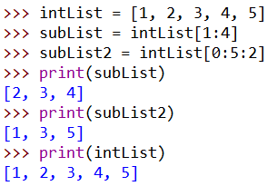Image 4.12: Creating a slice.

To get a slice from a specific index until the end of
the list, including the last element, only the starting
index is required along with the colon [61]. In a similar way, if one wants to get a slice from the beginning of
the initial list till a specific index, only the ending index
is required along with the colon in front of it.
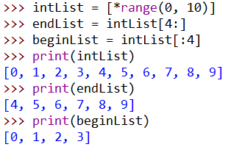Image 4.13: Creating sublists from/to a specific index.

Removing all items in a list, can be achieved by calling the clear() method [66].
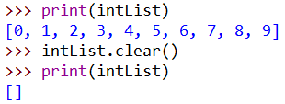Image 4.14: List's clear() function usage.

Append, Insert, Extend, Remove & Pop
A list has the ability to increase or decrease in size. This is done by adding new elements to it or removing old ones, through the following five methods [66]:
- list.append(element)
  - It adds the element argument, at the end of the list. The given element can be anything, even another list, which is stored in a single index rather than adding each element of the argument list at the end of the initial list. Appending can also be done with the += operator for scalar values, but when used with a list as the right side operand, it will work like extend() rather than append().
- list.insert(element, index)
  - Inserts the given element, at the given index, pushing the existing elements at that index and after to the next index.
- list.extend(element)
  - Combines the list with the element, which must be an iterable(list-like) type. Extending can be used to create a list of sequences, like in the example of Image 4.15, which is simpler than using the unpacking operator. Extension can be achieved by using the += operator with the right side operand being another iterable object.
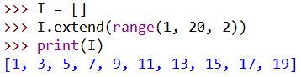Image 4.15: Using the extend() function.

- list.remove(element)
  - Removes the first occurrence of the element value, if exists, else raises a ValueError.
- list.pop(index)
  - Removes the value at the given index (or the last one if index is not given) and returns it.

Sort & Reverse
Usually, big data sets are processed better, in many situations, when sorted in some way, due to the fact that following a specific order, a programmer can choose to only modify specific elements without iterating over the others. This can save up on computing time and deliver results faster than having to iterate over all elements of a list and checking if they match the criteria for which they need to be modified.
Sorting a list, in an ascending or descending order, can be done with the method sort() [67], as long as there are data of similar type inside the list.
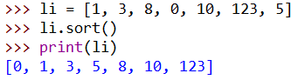Image 4.16: Sorting a list.

Without passing any arguments, sort() sorts in an ascending order. Passing the argument reverse = True,
makes the method sort in the opposite order. The
parameter `reverse` is called an optional parameter,
which will be explained in the next chapter, along with how to retrieve this kind of information.
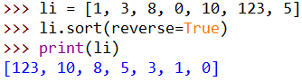Image 4.17: Sorting in the reverse direction.
Reversing a list, whether sorted or not, can be done with the reverse() method [66] and by indexing, but the latter requires the programmer to remember to assign the reversed list back to the variable, whilst the method call does it automatically.
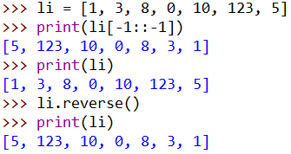Image 4.18: Reversing a list.

Count & Index
In order to get the information on how many
times a certain elements appears in a list, due to
the nature of this problem, it can easily be solved
with the use of a for loop and a counter variable.
Since it is a common thing for a programmer to
require, Python offers us the count(element-value)
list method [65] which does the same thing.
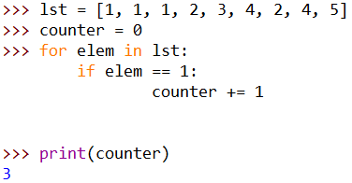Image 4.19: Counting the occurrence of an element.

The first occurrence of an element in a list can be found by using the index(element-value) method [65]. If the passed element exists, it will return it’s index. If the element does not exist, the method will throw a ValueError exception. This can be avoided
by either wrapping the call in a try – except statement or doing
conditional checks, such as checking if the parameter to be given to the index() method exists in general in that list.
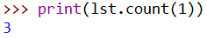Image 4.20: List's count() function.
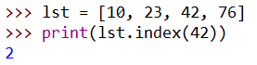Image 4.21: List's index() function.

Strings
The String data type, although not a normal
list, can actually be considered and therefore manipulated as a list [7]. It is easy to remember that a string is a concatenation of alphanumeric characters. Image 4.22 showcases some list functionality being used with a String variable.
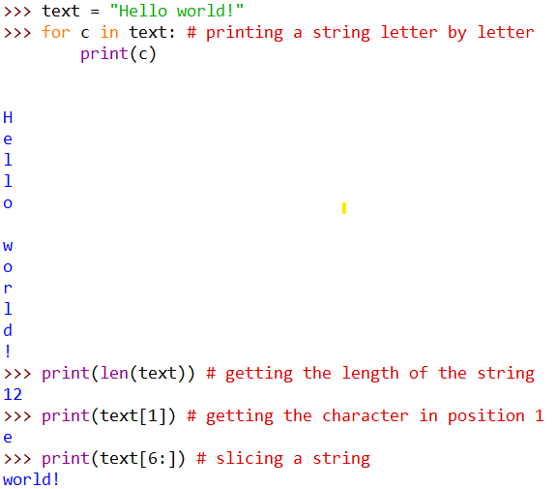Image 4.22: Manipulating a String as a list.
As seen, only basic functionality is common
between Strings and Lists, like slicing or element retrieval, whilst some methods of a list object is not usable with a string variable. Strings contain other methods which are suggested to be looked up in
the relevant documentation page.

The in operator: finding if an element is in a list
Many times, a programmer is interested in
finding if a specific value or values are
(or are not) part of a list of values. In Python,
this can be achieved by using the in operator
[46], [65], which checks if the left operand is as
a single index, meaning a single value entry,
in right operand list. Checking if an element is
not inside a list is done by combining the not and the in operators like shown in Image 4.23.
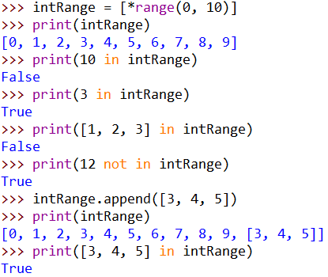Image 4.23: Using the in operator.
In the image, using a list display with a starred
expression as shown earlier, a numerical sequence
is created. After checking if two scalar values are
part of the list, the in operator is used to check if a
list containing the numbers 1 through 3 is a part of the right hand list. It is important to note that the in operator does not perform element-wise checking, as in checking if all elements of the left operand are part of the right list operand, but rather if the entire left operand is contained in the list. After checking if another scalar value is part of the initial list, a new single element is appended to the list. This element would be accessed by writing intRange[10] and is considered as another single element of the initial list. At this point, intRange is considered as a list containing values of two different data types, ones being of type integer and one being of type list. It can not be considered as a 2-D array, as not every element of it is a list of the same length.

Comparisons with MATLAB
As stated in a previous chapter, all variables in MATLAB are matrices. This means that instead of being able to append a new element, the matrix is concatenated with it, creating a new one which is saved to the same or a new variable [68]. Unlike Python, Strings in MATLAB, which are double quoted, can not be manipulated like lists/matrices whilst character vectors, which are single quoted strings, can [69]. The equivalent to the in operator in MATLAB is the ismember() function which takes two arguments, the first being the element to see if it is contained in a matrix and the second being the matrix to check.
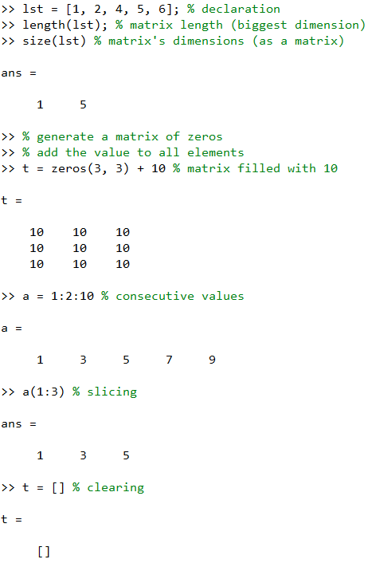Image 4.24: MATLAB code manipulating matrices, part 1.
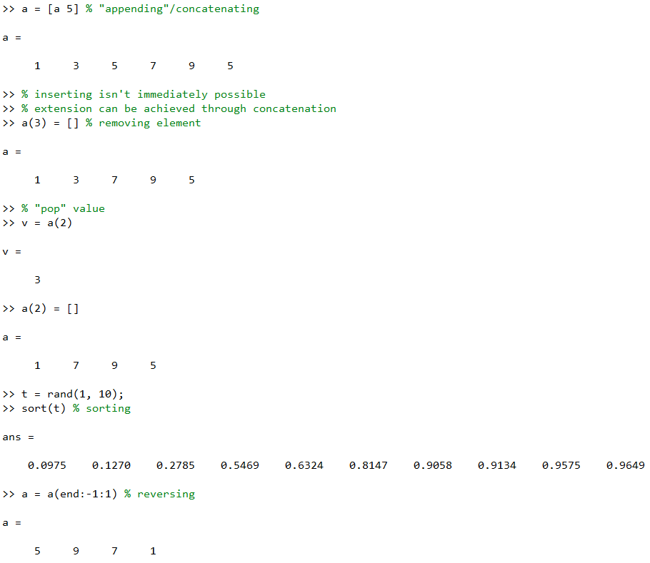Image 4.25: MATLAB code manipulating matrices, part 2.
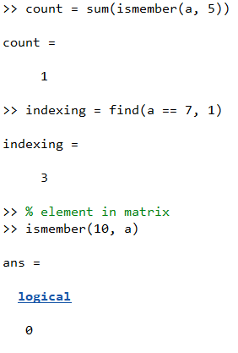Image 4.26: MATLAB code manipulating matrices, part 3.
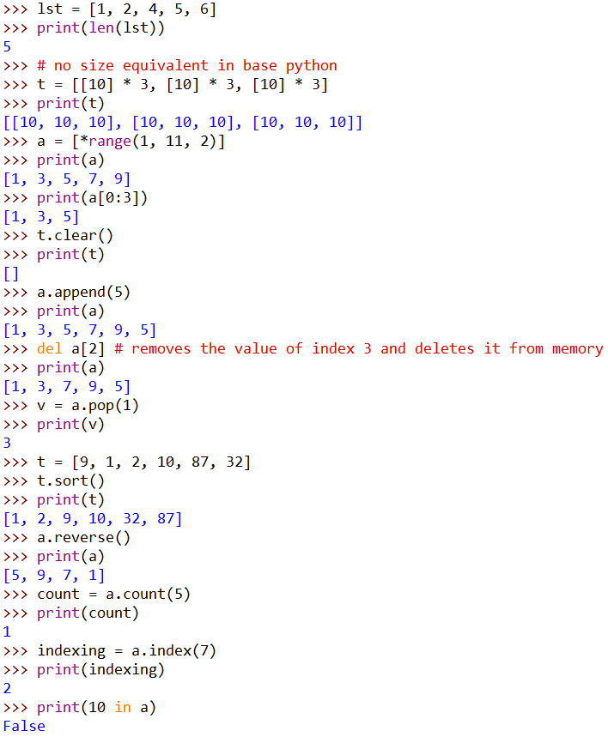Image 4.27: Python equivalent code of Images 4.24 through 4.26.

Functions
Functions are callable code that take arguments and produce a result, that they may return it back to the place where the function was called or not. All functions return a value, even print(), but it depends on the implementation of said function to know if the returned value is usable or not. The arguments a function may require, can be declared as optional if need be. A function's name, argument types and the returned value type is called the signature of the function.

Built-in Functions
To get information about a declared function, a programmer can use the help() function, passing as an argument the function’s name they want to lookup [70], quoted or not. To see information about the print() function, for example, the initial function would be invoked like in Image 5.1.
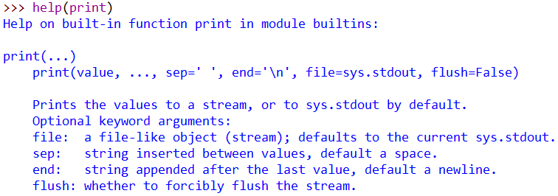Image 5.1: Getting information for print() using help().
As seen in Image 5.1, print() takes the following arguments:
- print(value, …., sep=' ', end='\n', file=sys.stdout, flush=False)
  - value, ….: Required. A comma separated list of values to be printed.
  - file: Optional. A file-like object, allowing to save the values to a file rather than printing them. If not specified, it defaults to sys.stdout, which is the console.
  - sep: Optional. A separator character that's inserted between values. If not specified, it defaults to a whitespace.
  - end: Optional. A character to append at the end of print. Defaults to the newline escape character ‘\n’.
  - flush: Optional. A boolean value that specified whether to forcibly flush the buffered output. We will not get into detail as to what flush does, as it is out of the scope of this document. Defaults to False.

In a similar manner, using help(), information about all used functions from the previous chapters can be acquired. Listed below, are some of them:
- input(prompt=None)
  - prompt: Optional. String value for the function to print before getting input from the user. Defaults to None, a built-in value that represents null/nothing.
- len(obj)
  - obj: Returns the number of elements in the obj container.
- range(start, stop[, step])
  - start: Optional. Specifies the start of the sequence. Defaults to 0.
  - stop: Specifies the end of the sequence, without including it.
  - step: Optional. Specifies the step of which the sequence is generated. Defaults to 1.
- int(x, base=10)
  - x: Optional. A string or number to turn into an integer number. If x is float, then the decimal part is truncated.
    - If omitted, function returns 0.
  - base: Optional. Specifies the base of the numbering system to be used to read the string. Defaults to 10, the decimal numbering system.
- float(x)
  - x: Optional. A string or number to turn into a floating point number.
    - If omitted, function returns 0.0.

Besides the above, there are many more useful built-in functions Python offers [71]:
- abs(x)
  - x: any of the number types or Complex object.
    - Returns the absolute value of the integer or floating point number or, in the case of a Complex object, its magnitude.

- all(x)
  - x: Iterable object.
    - Returns True if all the elements in the object are True or exist, False if it's empty or all elements are False.
- any(x)
  - x: Iterable object.
    - Returns True if at least one object is True or exists, False otherwise.
- bool(x)
  - x: Any type of object.
    - Returns True if the object exists, False otherwise or if omitted.
- chr(x)
  - x: Integer type.
    - Returns the Unicode symbol that is associated with the parameter value. Reverse of ord() function.
- complex(real, imag)
  - real: Optional parameter. The value of the real part of the complex number or a string that represents the complex number in the form of "real + imag j".
  - imag: Optional parameter. The value of the imaginary part of the complex number. Must be omitted if real is a String representations of the complex number.
    - Returns an object that represents the Complex number type.
- divmod(a, b)
  - a, b: Non complex number type parameters.
    - Returns a pair of numbers consisting of the output of the integer division and modulo operations. Equals to (a // b, a & b). The values can be accessed like elements in an array.

- max(i) or max(arg1, arg2, …., argN)
  - i: Iterable object. Usually containing number type of elements, except complex.
  - arg1, …., argN: Multiple arguments. Usually number types.
    - Returns the largest element or argument, based on what was passed as a parameter.
- min(i) or min(arg1, arg2, …., argN)
  - Identical to max() function but instead returns the smallest element or argument.
- ord(x)
  - x: String of length 1, a character.
    - Returns the code associated with the parameter value. Based on the Unicode table.
- pow(base, exp, mod)
  - base: Non complex, number type parameter.
  - exp: Non complex, number type parameter.
  - mod: Optional parameter. Non complex, number type parameter.
    - If only the two required parameters are present, the returned value is equivalent to using the power operator: base ** exp.
    - If all three arguments are present, returns the base to the power of exp, modulo mod, which is computed more efficiently than manually doing pow(base,exp) % mod.
- sum(i, start)
  - i: Iterable object of number type elements, including complex.
  - start: Optional parameter. Initial value on which to add all the elements of i.
    - Returns the sum of all the elements.

Creating Functions
Although the built-in functions are commonly used,
programmers regularly have code snippets which they
reuse. Having to rewrite them each and every time they
want to use them is tedious and can waste their time. For
this reason, user defined functions are possible to be
created. In Python, defining functions can be achieved
similarly to the example of Image 5.2.
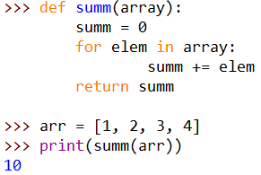Image 5.2: User defined function.
In order to define a function, the def keyword
along with the function’s signature has to be written followed by a colon [72], [73]. Then, anything belonging to that function must be indented at least by one level. From then on, the rules still apply, like extra indentation for if/for statements, etc. Lastly, if the function has to
return something, the return keyword along
with the value or variable is written. This isn’t required to be written as the last line of a
function, as the value returned may change
based on a conditional decision tree. If not,
then the return keyword can be omitted and
the function will automatically return None,
a special value that signifies the state
‘empty’/’no value here’. So even if a function
does not explicitly return something, it implicitly
returns None [72]. A function can return any
type of value or data structure, be it an int, float,
String, boolean, list or other. It is important that a programmer first defines a function and then uses
it, as the opposite would not work.
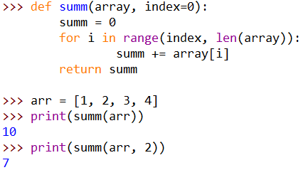Image 5.3: Using optional parameters in function signature.
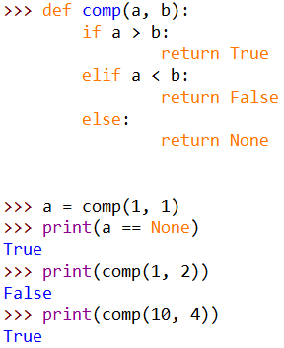Image 5.4: Returning a value based on conditions.
When looking at the built-in functions, the
concept of optional parameters was brought up.
User defined functions can as well contain optional parameters, by specifying a value for each one in the function signature [74].

Using created functions
Even with user defined functions, a programmer would
have to rewrite each function they wanted at least once per program in order to use them in many projects. In order to avoid such situations, Python allows the programmers to write functions in files and then import them into other
ones. The example in Image 5.5, shows how to import the functions from the examples of the previous chapter,
inside another Python script file that is located inside the
same directory as the file containing them, named functions.py.
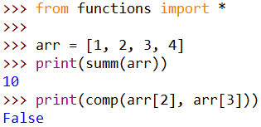Image 5.5: Importing functions from other files.
The statement from functions import * means: “from the file named functions.py import everything". If only one of the two functions was needed, the initial statement would be rewritten as in the snippet of Image 5.6. If the file had multiple functions and only a couple were required, the function names would be written as a comma separated list after the import [75], [76].
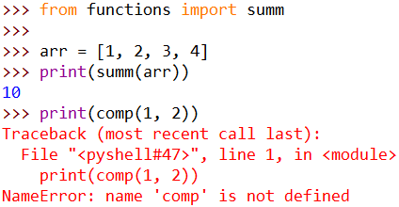Image 5.6: Importing specific functions from other files.

Imported functions can be given an alias, a different name to call them with [76], as shown in Image 5.7.

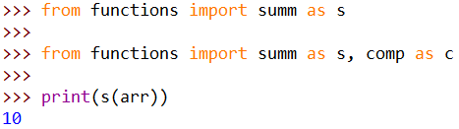Image 5.7: Importing functions with an alias.

Comparisons with MATLAB
MATLAB also has a help() function which can be used in two ways [77]. It also contains the doc() function [78], used similarly to the first, which opens up the website page of the documentation of the given parameter. It shares similar built-in functions to Python, either named the same or differently, whilst it misses some as there are operators for doing the same thing. Creating functions in MATLAB uses the following syntax whilst also having to name the file the same as the function’s name, thus having one function per file [79].

function [output1, output2,…, outputN] = functionName(param1, param2, …, paramN)
…
end

And to use functions declared elsewhere, their files only need to be in the active workspace directory or MATLAB’s Paths.

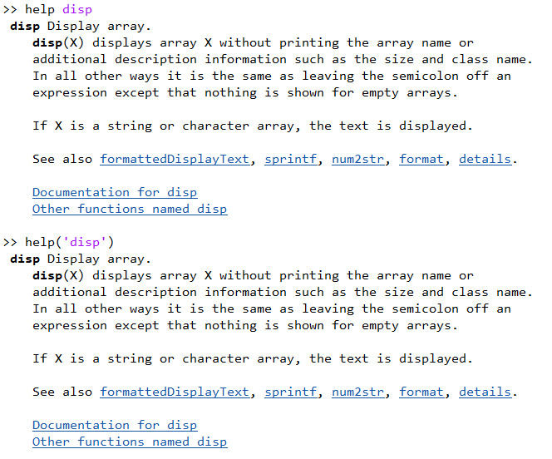Image 5.8: MATLAB's help function.
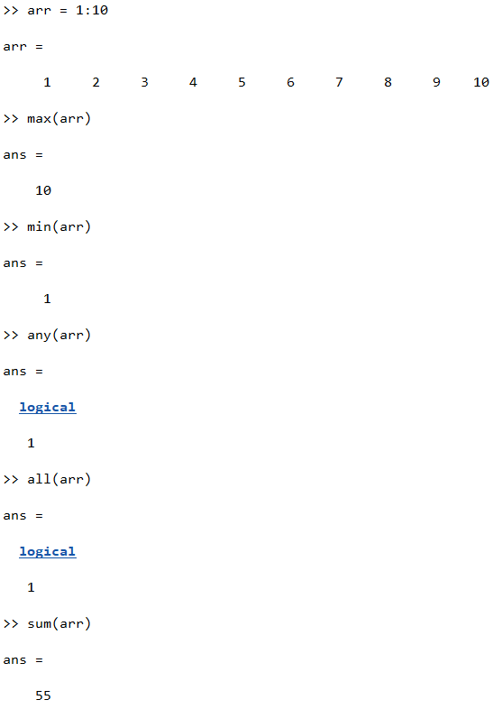Image 5.9: Using some of MATLAB's built-in functions.
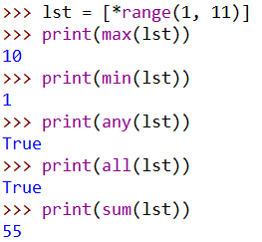Image 5.10: Python equivalent code of Image 5.9.
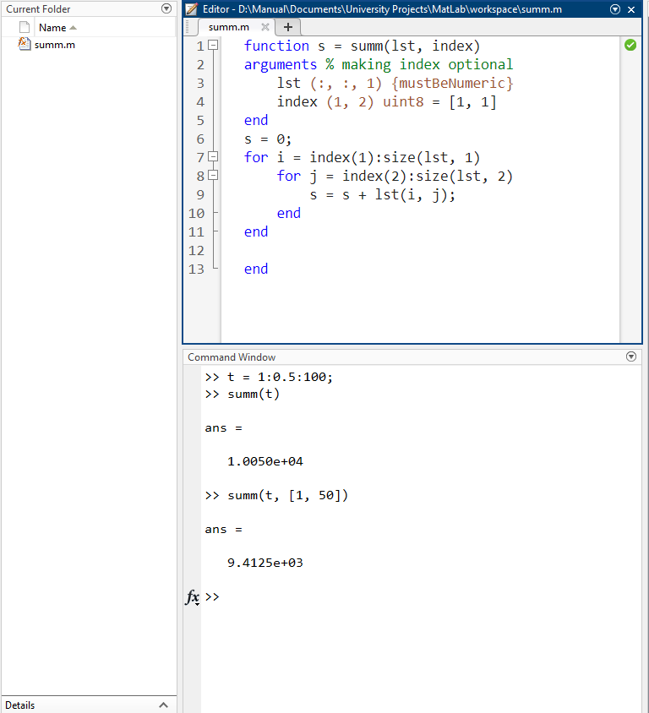Image 5.11: Writing and using a custom function in MATLAB.
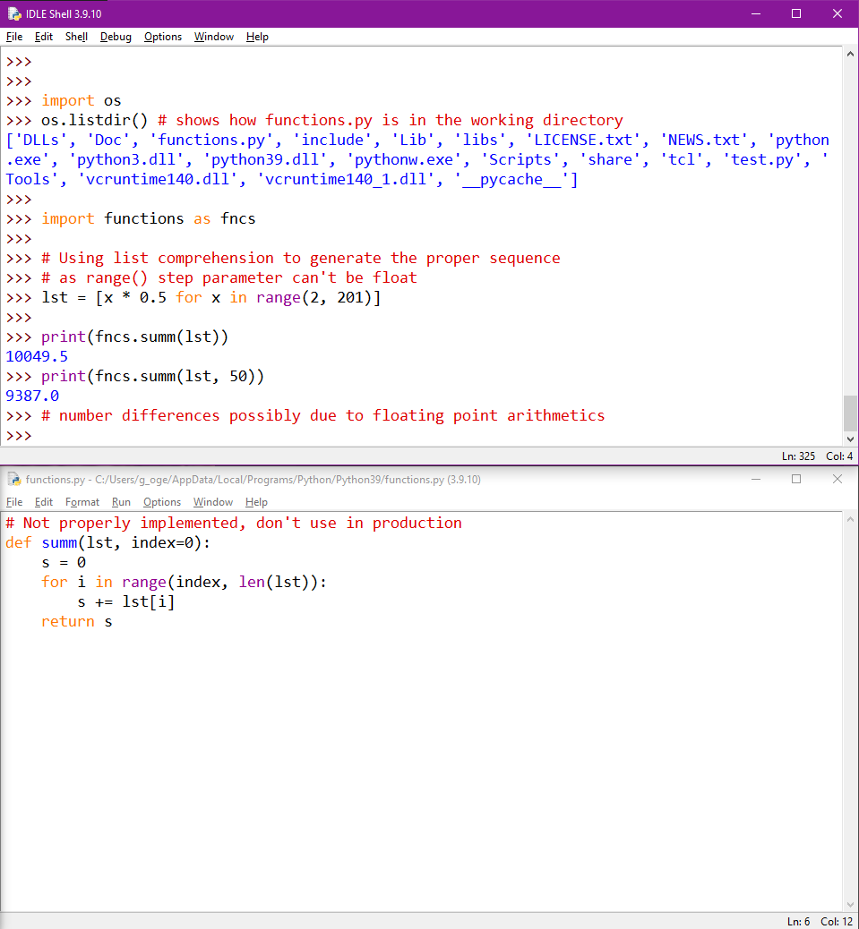Image 5.12: Python equivalent code and environment of Image 5.11.

File manipulation
Being able to programmatically manipulate files, helps in the creation of software with increased capabilities, since it opens up a whole new world of possibilities, like saving the last state of our program, making backup copies of files used at runtime and so on.
Python has a simple way of accessing and using files inside scripts. Using the built-in function open(file, mode='r'), the file’s contents are available in the program [80]. The parameter file is of type string and should be the file name contained in a relative or absolute directory path, whether the file exists or not. If the file doesn't exist and the default mode value is passed, or one of similar functionality, Python will throw an error. If a proper mode (write-like mode) value is given, a non-existent file will be created automatically by Python. The value of mode can be one of the following [81]:
- r: default value. Opens the file in read-only mode.
- w: Opens the file in write-only mode. If used on an existing file, it will replace all contents of it with what Python is instructed to write.
- a: Opens the file in appending mode. Any content Python is instructed to write, will be added at the end of the file.
- +: Opens the file for updating it’s content, allowing both read and write operations.
- r+: Opens the file in read-and-write mode, with no truncation.
- w+: Opens the file in read-and-write mode, with truncation.
Additionally, along with any of the above modes, adding 't' or 'b', opens the file in text or binary mode, respectively. If text or binary mode are not specified, it falls back to text mode.

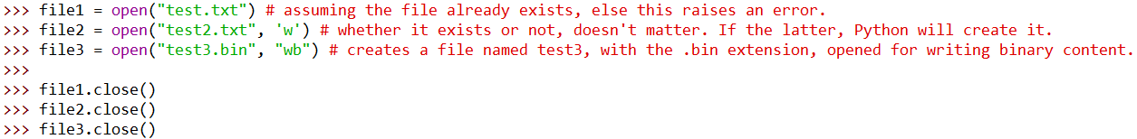Image 6.1: Opening and closing a file in Python.
In the code example of Image 6.1, it is shown how the
open connection to the file is closed, by calling its close() method [80]. In essence, close() flushes and closes the I/O stream. That means that it empties any and all Input/Output
data buffers for that file and then closes the Input/Output
connection to it. Files contain a boolean variable that allows
us to check if a file is closed or not.
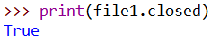Image 6.2: Checking if the file is closed or not.

Reading files
Reading the content of a file can be done in many ways, depending on what the programmer wants to do. Python can read the content all at once, line-by-line or only a specific portion of it. From each reading operation, the file’s cursor is moved to a new location, which can then either be reset so that the file can be reread or return it’s location. For the example of Image 6.3, the test.txt file contains the following four lines:
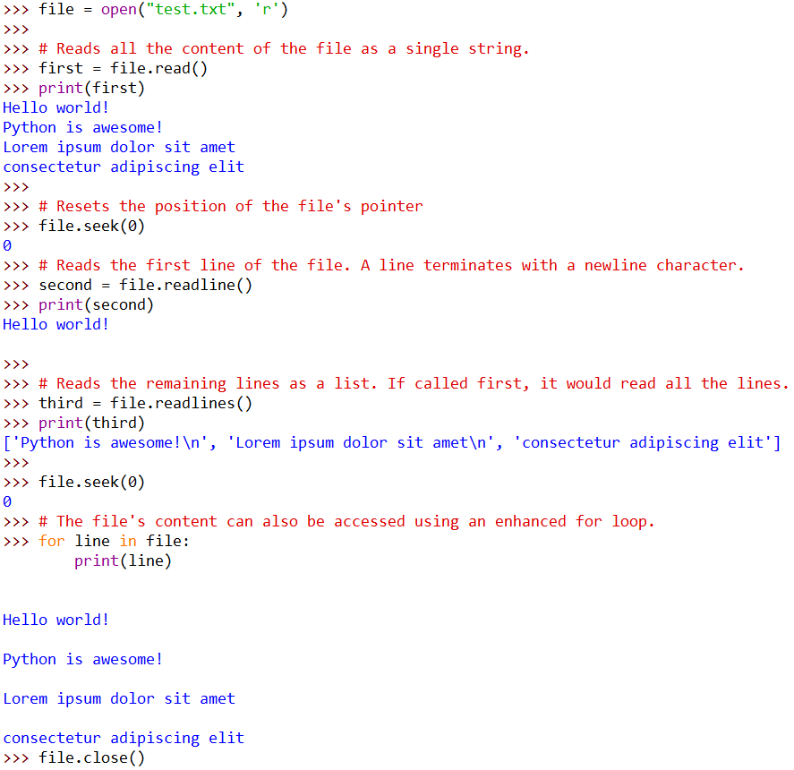Image 6.3: Reading the content of the file 'test.txt'.

Hello world!
Python is awesome!
Lorem ipsum dolor sit amet
consectetur adipiscing elit

In the same image, three file methods
are used in order to read a file’s content
and one method that moves the cursor to
another position [82], besides the
enhanced loop. These functions usage
is explained in the list below.

- file.read(size = -1): Reads at most
size amount of characters, or all of them if the size argument is omitted or negative.
- file.readline(size = -1): Reads until a newline character (“\n”) if the size argument is omitted or negative, or as many lines as specified by the size parameter until satisfied or reaching the End Of File (EOF).
- file.readlines(hint = -1): Returns a list of lines from the opened file stream. The hint optional parameter can be specified to control the amount of lined read, but no more lines will be read if the total size of all lines so far exceeds the hint.
- file.seek(offset, whence = 0): Changes the file’s cursor position by the given offset, relative to the position indicated by whence. Values for whence are:
- start of the file, offset should be zero or positive
- current cursor position, offset may be negative
- end of the file, offset is usually negative.
In order to find the cursor’s current position, the file.tell() method can be used.

Writing files
Although reading a file is quite valuable, writing to files is an extremely important. Similarly to reading
files, writing is as easy.
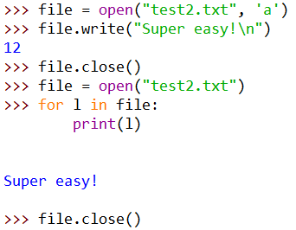Image 6.4: Writing a String literal to a file.
Using the file’s method write(), which takes a single argument of type String [82], anything can be appended to the file, as long as the file was opened in append
mode. If the file was opened in write mode, using the
'w' flag, the write() function would overwrite all the
content the file had, with the parameter value.

`with` keyword
File manipulation, simple as it may be in Python, isn't without disadvantages. Having to remember
to close the file when the programmer is done with
it, is many times forgotten and that leads to issues like file corruption, I/O blocking, etc. On another note, calling close() manually when using write() could result in incomplete writes. Luckily, the programmers of the Python language and interpreter, have provided a solution.
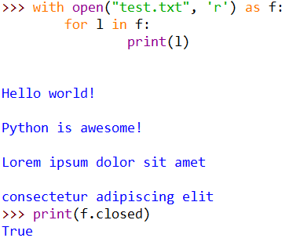Image 6.5: Using the with statement to edit a file.
The with statement can be used to open a file, work with it and when done, it will automatically close it [80]. As showcased in Image 6.5, without calling file.close(), the file was closed automatically.
When using the with statement, all code that
interacts with the file should be indented like when
using a for/if statements.

Comparisons with MATLAB
MATLAB’s ability to read and write files is similar to Python’s with the difference being that there is no certain way to automatically close a file I/O. Some functions, like readlines() [83], do it automatically while others don’t. Besides having to remember to close the file, the major difference between the two is that Python’s syntax follows the Object-oriented paradigm while MATLAB’s follows the Structured paradigm.

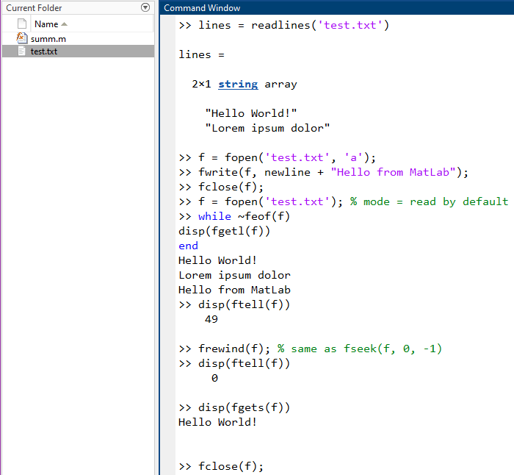Image 6.6: File manipulation in MATLAB.
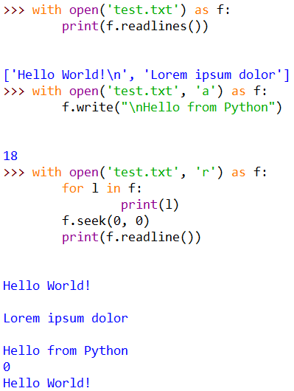Image 6.7: Python equivalent code of Image 6.6.

Modules
Pythons built-in functions, although plenty, offer little functionality when it comes to full scaled programs. It is possible to write a collection of function and constant values, which is called a library, but that would mean that teams of programmers would either have to choose one of the libraries each one created, fuse them all together or use each and every one of them to complete a project. And that would be impractical, since many functions would be similar, if not the same, so it would be impossible to choose a single implementation to use. For this reason Python offers a set of libraries called modules.
Modules are essentially collections of methods and constants that are all housed under a specific name, which can be imported in a Python script in order to be used. With these modules, a Python programmer can create more complicated programs as the tools at their disposal can be increased at will. Modules can also be created by programmers and shared with others. Creating custom modules can be as easy as writing functions in an external Python script file like shown in Chapter 5.3.

Importing and using built-in modules
Similarly to functions created in Python scripts, modules can be imported as well, either with the same from – import statement (using the module’s name after the from statement) or an import statement like shown below [75], [76]. The details of their difference will not be covered in this document, but as a general thought the from – import statement allows the programmer to use the function(s) imported from the file directly, which can lead shadowing of user-defined or built-in function, whilst the import statement does not induce shadowing but does import every function the file contains, allowing it to be used with a syntax similar to methods, an example of which will be given later.
Image 7.1: Importing the math module, without and with an alias.

math & cmath
The math module contains commonly used mathematical expressions, like sine, cosine, tangent, and constants, like π, e, infinity and a special NaN value, which stands for Not a Number [84]. Some of the most used functions are listed below. The methods of the math module do not work with complex numbers created by the complex() function.
- math.ceil(x), math.floor(x)
  - Rounds the parameter value up (ceiling value) or down (floor value) to the closest smallest integer that is greater than or equal to x, in the case of ceil(), or the largest integer that is less than or equal to x, in case of floor().

- math.fabs(x)
  - Returns the absolute value of the number x, as a float.
- math.factorial(x)
  - Returns the factorial of x as an integer. Raises an Error if the value isn't a positive integer.
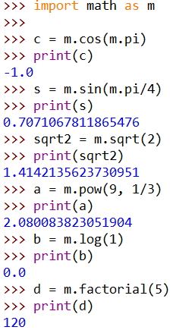Image 7.2: Using functions from the math module.
- math.fsum(x)
  - Returns the sum of all elements of the iterable x, without precision losses.
- math.prod(x, start = 1)
  - Returns the product of the elements of the iterable x. If x is empty, returns the value of the start optional parameter, default being 1.
- math.exp(x)
  - Returns e raised to the power of x. This functions
is more accurate than using math.e ** x or pow(math.e, x).
- math.log(x, base)
  - If only x is present during the call, the function returns the natural logarithm of x. If both arguments are present, returns the logarithm of x
to the given base.
- math.log2(x), math.log10(x)
  - Returns the base 2/base 10 logarithm of x. Usually more accurate than using math.log(x, 2) or math.log(x, 10).
- math.pow(x, y)
  - Returns x raised to the power of y. Unlike the built-in pow() function or the power operator **, math.pow() converts its arguments to floats.
- math.sqrt(x)
  - Returns the square root of x.
- math.cos(x), math.sin(x), math.tan(x)
  - Returns the cosine, sine or tangent of x radians.
- math.acos(x), math.asin(x), math.atan(x)
  - Returns the arc cosine, arc sine or arc tangent of x, in radians

- math.degrees(x), math.radians(x)
  - First one converts x radians to degrees, while the latter does the opposite.
- Constants
  - math.pi
  - math.e
  - math.inf
  - math.nan

As noted earlier, the math module cannot handle complex numbers. This is due to the fact that many mathematical functions, like the cosine, are calculated differently for them. For this reason, there is the cmath module, which stands for complex math. This module contains most methods the math module has, with the difference being that they are implemented based on complex numbers. Besides those, cmath has special methods and constants that are specific to it, like converting a complex number from rectangular to polar coordinates and vice versa [85].
- cmath.phase(z)
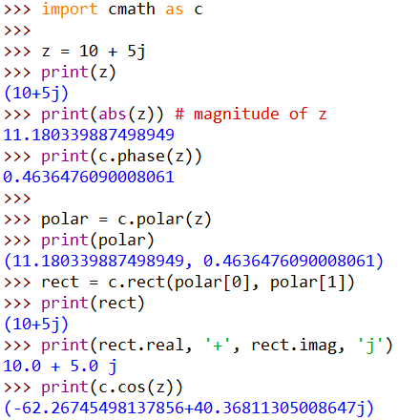Image 7.3: Doing complex math with the cmath module.
  - Returns the phase of the complex number z in radians as a float.
- cmath.polar(z)
  - Returns the polar representation of z, as a pair
(r, phi) where r is the magnitude and phi is the phase of z.
- cmath.rect(r, phi)
  - Returns the complex number z with polar coordinates r and phi.

- Constants
  - cmath.infj
    - Complex number with real part equal to 0 and positive infinity imaginary part
  - cmath.nanj
    - Complex number with real part equal to 0 and NaN imaginary part.
Complex numbers can also be created using the imaginary unit j, similarly to how it is done in mathematics.
z = # + #j where # is any number.
The real and imaginary part of complex numbers can be accessed by the real and imag constants of a complex variable.

array
Although lists are commonly used, they are not memory efficient due to the fact that they can contain values of multiple data types, or even other lists. If a programmer can be certain that the data inputted in a list is only of a specific type, the array module can be used to create memory efficient lists that store values of a specific type [86].
Array initialization is done through the array() function of the array module, that takes a parameter of a single character, which specifies the type of the data the array will contain. The list of characters, their corresponding type and their minimum byte size is shown below.
Type code | C Type | Corresponding Type | Minimum size in bytes
‘b’ | signed char | int | 1
‘B’ | unsigned char | int | 1
‘u’ | wchar_t | Unicode character | 2
‘h’ | signed short | int | 2
‘H’ | unsigned sort | int | 2
‘i’ | signed int | int | 2
‘I’ | unsigned int | int | 2
‘l’ | signed long | int | 4
‘L’ | unsigned long | int | 4
‘q’ | signed long long | int | 8
‘Q’ | unsigned long long | int | 8
‘f’ | float | float | 4
‘d’ | double | float | 8

Although many typecodes are assigned to the type int, there are differences between them due to how they were created in the C language, since Python is built on top of C. Generally, the differences are that signed types can contain values that are both negative and positive, while unsigned can contain only positive values and that each type can hold a different range of values.
Besides the memory efficiency, arrays can be manipulated exactly like lists and contain the same methods along with some array specific methods and constants, which are listed below.
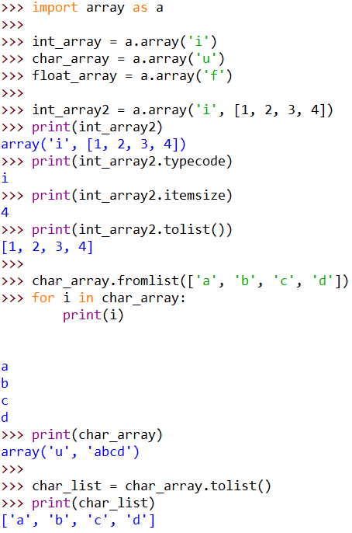Image 7.4: Array module and functions.
- array_variable.typecode
  - Returns the typecode used to create the array.
- array_variable.itemsize
  - Returns the size in bytes of one array item
in the internal representation.
- array_variable.fromlist(lst)
  - Converts the list to an array and stores it in the array_variable. Elements of list lst must be matching the type of the array_variable.
- array_variable.tolist()
  - Converts and returns the array to a list, which
contains the same elements as the array.

csv
One of the most commonly used file formats for storing data, is the Comma Separated Value format, also known as CSV. Although it is just a plain text file, it requires delicate parsing in order to not mess up the data. Instead of the programmers having to write a parser themselves, Python contains the csv module, which contains CSV readers and writers [87], that can be easily customized to the programmer’s preference.
This module, is used with file type objects, as the contents of a CSV file are first loaded as a whole and then parsed as a CSV format. That is why, the two entities managing CSV files directly, the reader and the writer, require a file-like variable to be given as a parameter. These two entities are not the only ones the csv module contains, but they are important tools to understand before moving to more specialized tools.
- csv.reader(csvfile, **formattingParameters)
  - Returns a reader object which has gone through the csvfile and has parsed all values per line. Each row read, is saved as a list, which can be accessed through a for loop.
- csv.writer(csvfile, **formattingParameters)
  - Returns a writer object, which can write rows of data in a CSV format, that can be customized to the programmers needs. The writer object, contains the following two methods that enable the writing process.
    - writer.writerow(row)
      - Writes the contents of the row variable to the targeted file. This variable needs to be a one dimensional list for the best output, but can be of more dimensions which is not suggested.
    - writer.writerows(rows)
      - Writes the contents of the rows variable to the targeted file. This variable needs to be a two dimensional list for the best output, but can be of more dimensions which is not suggested.

Both the reader and the writer can take optional parameters, called formattingParamaters [88], which customize many aspects of the read/created CSV file. Among them, the most common are:
- delimiter: one character string used to separate fields, defaults to a comma character
- quotechar: one character string used to quite fields, defaults to a double quote character
- quoting: controls when values are quoted. Can be one of the following values:
  - csv.QUOTE_ALL: quotes all fields (writer exclusive),
  - csv.QUOTE_MINIMAL: quotes only fields which contain special characters such as the delimiter, quotechar, etc (writer exclusive),
  - csv.QUOTE_NONNUMERIC: writer quotes all non-numeric fields, reader converts all non-quoted fields to float,
  - csv.QUOTE_NONE: writer never quotes, reader performs no special processing of quote characters.

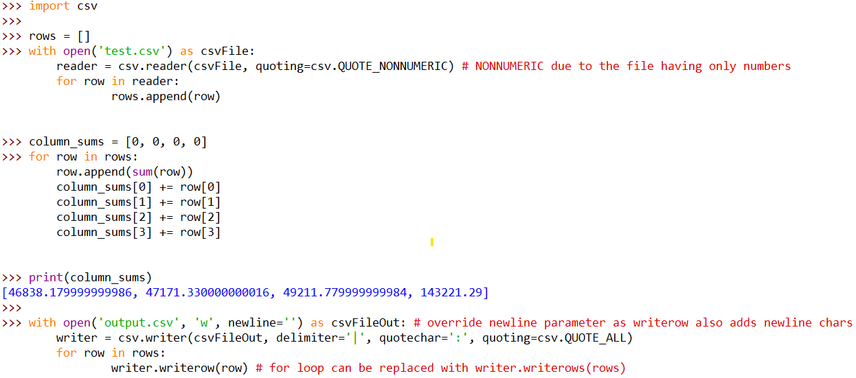Image 7.5: Using the csv module to read and write a CSV file of numbers.

Third party modules
Python is a powerful tool on it’s own, due to the easy syntax and many quality of life statements/expressions/functions it contains. Although it’s ecosystem of modules and functions is big, it is missing capabilities that programmers need for their fields of work. Since modules can be created by programmers as well, many teams worked hard to create some of the most powerful modules that are used in Python, both by professionals and amateurs. These are called third party or external modules, because they have to be downloaded and installed in the programmer’s system to be able to be used. Luckily, Python contains a tool called Package Installer for Python, also know as pip. It is a great software that makes the downloading and installing external modules much easier. More information on pip and how to use it in Appendix C: Pip & Virtual Environments.

NumPy
Doing matrix oriented mathematics is important to many fields of programming. Python by itself contains no way to perform those, besides programmers creating functions using for loops in order to perform
multiplication or addition.
This is solved by NumPy, one of the most popular libraries for Python, which contains an incredible amount of mathematical functions, including linear algebra ones.
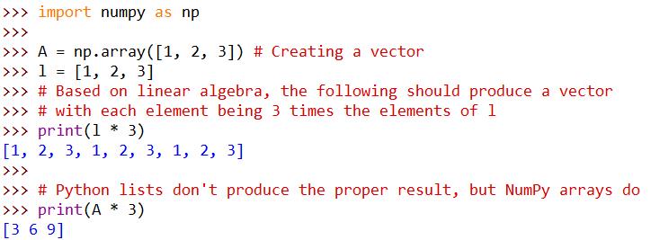Image 7.6: Proper matrix multiplication with NumPy
Performance-wise, NumPy is much more efficient in calculating matrix oriented functions than implementing for loops that does the same
thing. In Image 7.7, the datetime module is used
to measure the time [89] required for a for loop based and a NumPy based element-wise
calculation. As seen, the latter’s efficiency is overwhelming. Below, some important NumPy functions are listed, but they are only a small fraction of the whole library.
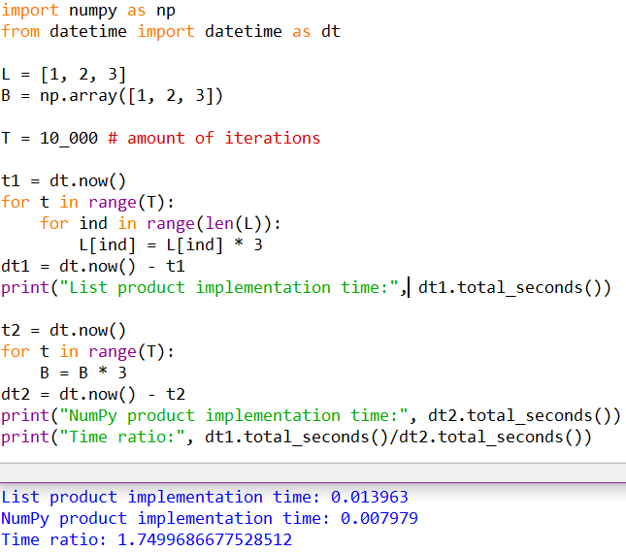Image 7.7: Execution time of element wise multiplication.
- numpy.array(list) [90]
  - Returns an array object of the numpy module (numpy.ndarray [91]).
- numpy.arange(start=0, stop, step=1) [92]
  - Returns a numpy.ndarray containing values starting from the start variable, up to, but excluding, the stop variable, based on the step given.
- numpy_array_var.reshape(newshape) [93] or numpy.reshape(arr, newshape) [94]
  - Transforms the shape of the matrix based on the passed parameter, newshape may be a single int or multiple of them. The dimensions requested must be able to be done using no less and no more than the amount of elements inside the array.
- numpy.linspace(start, stop, num = 50, endpoint = True) [95]
  - Returns a linear spaced numpy.array containing an amount of elements equal to num, evenly spaced inside the range of start to finish. If endpoint is set to True, then the stop value is included in the range, otherwise it is excluded.

- numpy_array_variable.dot(arr) [96] or numpy.dot(arr1, arr2) [97]
  - Calculates the dot product of the two vectors.
- numpy.eye(N, M = None, k = 0) [98]
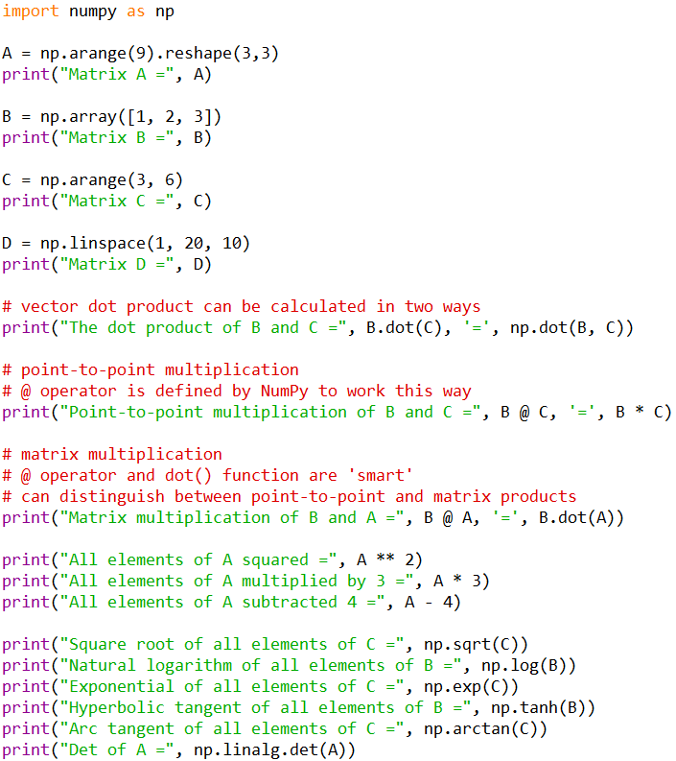Image 7.8: Performing matrix calculations with NumPy.
  - Returns the identical matrix with dimensions NxM, where M defaults
to being equal to N if omitted. Parameter k corresponds to the diagonal’s index, 0 being the main
diagonal, a positive number being
an upper diagonal and a negative
value being a lower one.
- numpy.ones(shape) [99]
  - Returns a matrix, with dimensions based the shape parameter, with all values being ones. shape can be a
scalar vale or a sequence, e.g. 2 or
(2, 3), parenthesis or brackets required for more than one dimension. A scalar shape
value is used for both rows and columns.
- numpy.zeros(shape) [100]
  - Similar to numpy.ones() but instead of ones, all values are set to zero.
- numpy.full(shape, fill_value) [101]
  - Similar to numpy.ones() and numpy.zeros(), but instead of ones or zeros, all values are set to fill_value.
- numpy.sqrt(arr) [102], numpy.log(arr) [103], numpy.log2(arr) [104], numpy.log10(arr) [105], numpy.cos(arr) [106], numpy.exp(arr) [107]
  - Element wise calculation of the square root (numpy.sqrt(arr)), natural logarithm (numpy.log(arr)), base 2 and base 10 logarithms (numpy.log2(arr), numpy.log10(arr)), cosine (numpy.cos(arr)) (similarly, other trigonometric functions exist) and exponential of each one (numpy.exp(arr)). Returns a new numpy.ndarray with the results.
- numpy.sum(arr) [108], numpy.prod(arr) [109]
  - Returns the sum/product of all elements inside the arr.
- numpy.linalg.det(matrix) [110]
  - Returns the determinant of the matrix parameter.
- numpy.linalg.inv(matrix) [111]
  - Returns the inverse of the matrix parameter.
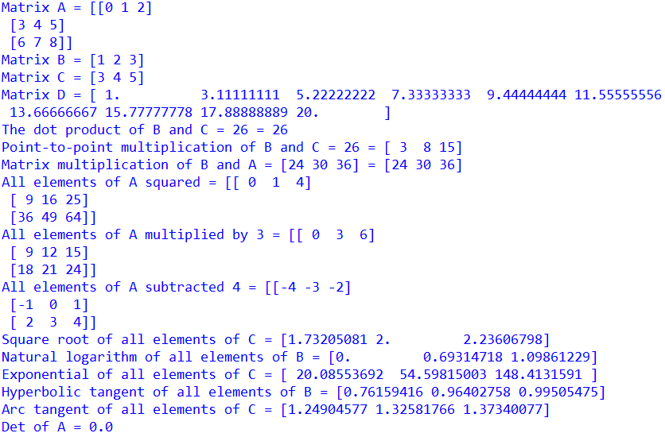Image 7.9: Results of test code from Image 7.8.

Accessing the elements, or a
sub-matrix, of a numpy.ndarray can in two ways. One is similar to how an element of a list would be accessed,
using one or two sets of square brackets. The other way, is using a single set of
square brackets and inside it separating with a comma the value of the row and column (and any other dimensions
index in case of more than 2 dimensions) of the element to be extracted [112].
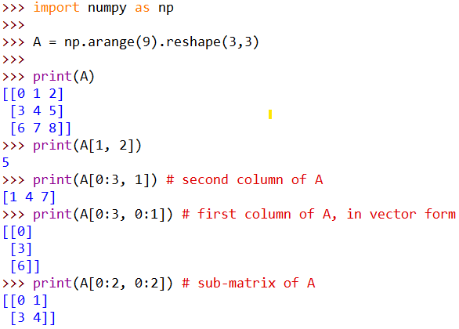Image 7.10: Accessing NumPy array elements and sub-arrays.

matplotlib & Pillow
Many times, it is important to visualize the data of a problem or the progress of it. Python, by default, does not have a way to plot data or display images. To solve this, a programmer can install third party modules, the most popular of which is matplotlib, a library that contains data and image visualization methods. Specifically, the pyplot module from matplotlib offers such functionality. One important feature of this module is that it woks with NumPy arrays when it comes to visualizing data. Below are some important methods of the matplotlib.pyplot module.
- pyplot.plot([x], y, [args]) [113]
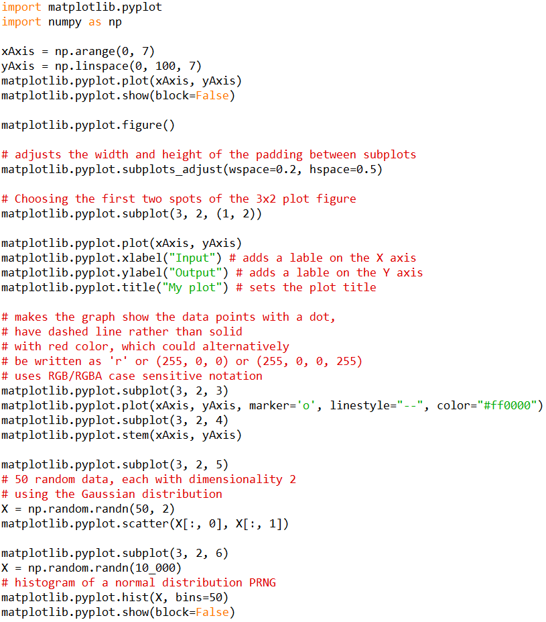Image 7.11: matplotlib.pyplot plots example. Using an alias for the module is suggested.
  - Plot y against x. Parameter x
and args are optional.
- pyplot.stem([x], y, [args]) [114]
  - Creates a stem plot of y against x. Parameter x and args are optional.
- pyplot.scatter(x, y) [115]
  - Creates a scatter plot of y
against x.
- pyplot.hist(x, bins = None) [116]
  - Plots a histogram from the values of x. The bins parameter defines the number of
equal-width bins in the range, defaults to 10.
- pyplot.semilogx([x], y, [args]) [117]
  - Makes a plot with the x axis being log scaled. Parameter x and args are optional.
- pyplot.semilogy([x], y, [args]) [118]
  - Same as pyplot.semilogx() but for the y axis.
- pyplot.loglog([x], y, [args]) [119]
  - Makes a plot with log scaling on both axes. Parameter x and args are optional.
- pyplot.figure(num = None) [120]
  - Creates a new figure or activates an existing one.

- pyplot.subplot(rows, columns, index) [121]
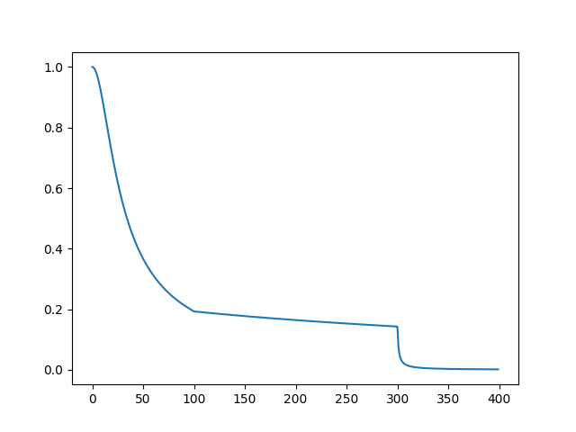Figure 8.3: Initial response curve of RC filter.
  - Adds new axes to the current figure or retrieves existing ones. The parameters can be passed in separately or all together as a three digit number, e.g. 132, which can only be used if there are no more than 9 subplots, as it would then not be a three digit number. The index parameter can be given as multiple values in parenthesis as well, e.g. pyplot.subplot(3, 2, (3, 4)), in the case that a plot should cover multiple positions.
- pyplot.show(block = None) [122]
  - Displays all open figures. The block parameter controls whether to wait all figures to be closed or not before returning from the function call. When True, the GUI loop will run until all figures are closed and then the return will happen. When False, returns immediately after the figure windows are displayed.

Many of the methods contain an optional parameter called args. This is similar on all of them, due to them sharing similar functionality on the 2-D plotting space. This parameter is actually an assortment of many other parameters that are defined in this documentation page, in the Additional keyword arguments list. Clicking on one, opens up the page of the function that is called from that parameter using the value inputted for it.
The matplotlib.pyplot module also contains methods
that create 3-D graphs [123]. Although useful, these require
a better understanding of Matplotlib, which this document tries to cover to a certain extent.
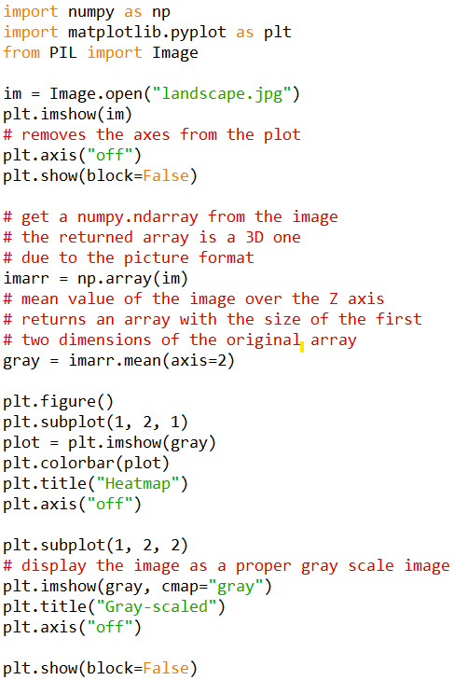Image 7.12: Using Pillow to load and manipulate an image.
Along with plotting capabilities, Matplotlib utilizes the Pillow module, besides NumPy. This module offers image processing capabilities when included in projects. The
reason it is included, is because Matplotlib can also
display images and integrates with Pillow’s Image [124] object class. Pillow integrates well with NumPy, and vice versa, since all images can be represented as matrices.
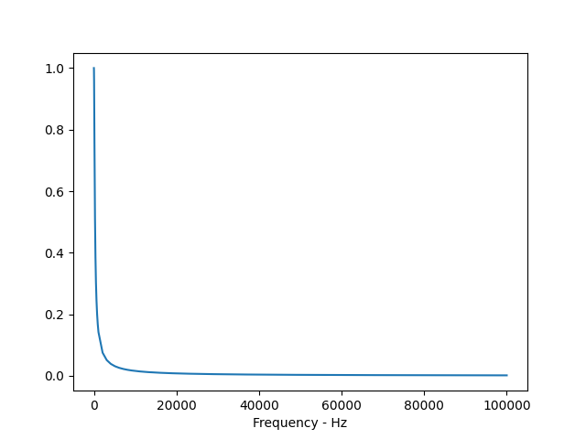Figure 8.4: New response curve of RC filter.
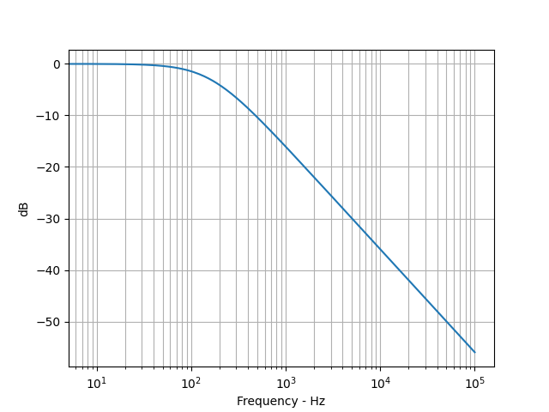Figure 8.5: Final response curve of RC filter.
An example is given in Image 7.12 on how Pillow, matplotlib and NumPy are used together to generate the heatmap and the grayscale version of an image.

Comparisons with MATLAB
MATLAB’s equivalent concept to modules are toolboxes. They function similarly, this being a collection of functions, constants and new data types, but they do not require to be imported explicitly as they reside in MATLAB’s Paths, hence being available right away.

Examples & Exercises

Examples
- Example
  - Problem Statement
We have 40 coins of 50 cent value, 40 of 1€ value, 40 of 2€ value and 40 banknotes of 5€ value. Develop a Python script which:
    - Will calculate and display all possible coin and banknote combinations that total up to 40€ using a total of 40 coins and banknotes, using any amount from any value.
    - Will calculate and display the number of possible combinations
  - Indicative Solution
For the algorithmic solution of the above example we illustrate with the following variables the elements of the problem:
x : the number of coins with a value of 0.5 euro
y : the number of coins with a value of 1.0 euro
z : the number of coins with a value of 2.0 euro
w : the number of banknotes with a value of 5.0 euro.
It appears that, using for loops, we can represent the potential values of the number of coins and banknotes. For example, the command for x in range(0, 41) indicates that the variable x (the number of coins with a value of 0.5 euro) can take any integer value from 0 (i.e. no coins with a value of 0.5 euro) to 40 (all coins with a value of 0.5 euro). Moving on, we wish to calculate the number of coins such that a total of 40 elements are used. This notion, can be written with the following expression: x + y + z + w. Similarly, the expression for the representation of the total value of all the coins and banknotes is: x * 0.5 + y * 1 + z * 2 + w * 5. The code below gives the proposed solution:
PS = 0
for x in range(0, 41):
for y in range(0, 41):
for z in range(0, 41):
for w in range(0, 41):
syn_plithos_nom = x + y + z + w
syn_aksia_nom = x * 0.5 + y * 1 + z * 2 + w * 5
if syn_plithos_nom == 40 and syn_aksia_nom == 40:
PS += 1
print(f"Combination #{PS}: {x}x0.5E {y}x1E {z}x2E {w}x5E")
print(f"PS = {PS}")
Save the above code as a file named exe1_1.py. Afterwards, you can run it in the following ways:
i) Open a command line terminal and use the cd command to change into the directory the file is saved in, then write the command python exe1_1.py. Use the appropriate python command based on your OS as explained in Appendix A.
ii) Open an interactive Python shell or IDLE session and copy paste the code there.
  - Implementation of the exercise using a Python function
In case we wanted to solve the exercise by using a function, we would have to see what could be the input and output of it. For example, we could be giving the function the value of the 4 coins-banknotes with it returning number of all the possible combinations. So, a possible implementation of it would be:
def ask1_1f(val1, val2, val3, val4):
PS = 0
for x in range(0, 41):
for y in range(0, 41):
for z in range(0, 41):
for w in range(0, 41):
syn_plithos_nom = x + y + z + w
syn_aksia_nom = x * 0.5 + y * 1 + z * 2 + w * 5
if syn_plithos_nom == 40 and syn_aksia_nom == 40:
PS += 1
print(f"Combination #{PS}: {x}x0.5E {y}x1E {z}x2E {w}x5E")
return PS
Save the above code as a file named exe1_1f.py. The function can be used by writing the following code in another Python script or a Python interactive shell or IDLE, as long as the file’s path is included directly (by appending it using Python’s os module) or indirectly (by being in the same directory) in the session’s paths.
from ask1_1f import ask1_1f
PS = ask1_1f(0.5, 1, 2, 5)
print(f"PS = {PS}")

- Example
  - Problem Statement
The mathematical formula that approximates expression e^{x} is given by the following formula:
Adding more terms to the summation, will improve the approximation. On the other hand, Python can approximate e^{x} with the exp(x) function of the math module as shown earlier. Develop a Python function my_exp_func(x) which accepts a scalar number and will calculate how many terms are required in the summation formula in order for the outcome to approximate e^{x} with an error margin of 10⁻⁵ compared to the output of the exp(x) function. That is, the following condition must apply:
  - Indicative Solution
For the algorithmic solution to this problem, we observe that the condition is a termination condition (TC). Given that we don’t know the amount of terms needed in order for the TC to apply, we will be using a while loop. We must consider that the while loop uses a continuation condition (CC) rather than a termination statement. We can transform the latter to the former by negating the comparison operators. This can be illustrated in the following way:
The above CC requires an update to the approximation term and an initialization of the e^{x} term using the math module’s exp(x) function.
Furthermore, we notice that the initial series can also be written as: which expresses a summation in the form of an iteration:
The variable i is the loop counter and is directly connected with the amount of terms used, like so:
The following code provides the suggested solution:
import math as m
def my_exp_func(x):
FIXED = m.exp(x)
S = 0
i = 0
term = x ** i / m.factorial(i)
S += term
while abs(S - FIXED) >= 1e-5:
i += 1
term = x ** i / m.factorial(i)
S += term
return i
Save the above snippet as a file named my_exp_func.py. The function can be used by writing the following code in another Python script or a Python interactive shell or IDLE, as long as the file’s path is included directly (by appending it using Python’s os module) or indirectly (by being in the same directory) in the session’s paths.
from my_exp_func import my_exp_func
x = 1
y = my_exp_func(x)
print("y = " + str(y))
The answer given by Python (“y = 8”) means that we need 9 terms to approximate e¹ with an accuracy of 5 decimal points by using the formula: .

- Example
  - Problem Statement
Developer a Python script that generates N numbers using the Fibonacci sequence, which is defined as :
  - Indicative Solution
The required script can be written using the following function:
def fib_non_recursive(N):
if N == 0:
return 1
elif N == 1:
return [1, 1]
else:
f = [1, 1]
for i in range(2, N):
f.append(f[i - 2] + f[i – 1])
return f
Save the above snippet in a file named fib_non_recursive.py. The function can be used by writing the following code in another Python script or a Python interactive shell or IDLE, as long as the file’s path is included directly (by appending it using Python’s os module) or indirectly (by being in the same directory) in the session’s paths.
from fib_non_recursive import fib_non_recursive
f = fib_non_recursive(12)
print("f =", f)
Also, it is known that this problem can be written using a recursive approach:
def fib_recursive(N):
y = []
for i in range(0, N):
y.append(my_fibo(i))
return y
def my_fibo(i):
if i == 0 or i == 1:
return 1
else:
return my_fibo(i - 2) + my_fibo(i - 1)
Save the code above in a file named fib_recursive.py. The function can be used by writing the following code in another Python script or a Python interactive shell or IDLE, as long as the file’s path is included directly (by appending it using Python’s os module) or indirectly (by being in the same directory) in the session’s paths.
from fib_recursive import fib_recursive
f = fib_recursive(12)
print("f =", f)
Notice that the output is the same in both occasions. The meaning of a recursive program is that a function calls itself until it reaches some base cases, in our example these are when i is equal to 0 or 1. Python supports the usage of recursion as shown.
- Example
  - Problem Statement
Once upon a time, in the distant China there was an emperor who had a passion for games – especially board games. But there came a day when he had played and had had enough of all the games there were. So he ordered a game with simple rules to be made for him, that each time he played it would be different so that he would never get bored. Anyone who could make him such a game could ask for any reward. So one of the one of his advisors thought of creating chess. The emperor was delighted and said to him, "What do you want your reward to be now? Does do you want to marry my daughter and become my heir to the throne?" "No" replied the advisor "something simpler. I want in the first of the squares of the chessboard to put a grain of rice, in the second two, in the third 4, in the fourth 8 and so on, each time doubling the number of rice grains. My reward will be all the rice on the top of the chessboard. on the chessboard." "Just that?" Said the emperor and ordered to pay the advisor immediately. But in the end, the rice they had to give to the advisor was so much that the emperor gave the whole property to pay him off.
Develop a Python script that:
    - Calculates the amount of rice grains that the advisor was given.
    - Keeping in mind that each rice grain can weight approximately 0.1 grams, calculates the total weight of the rice in tons.
    - Displays the message “The advisor gained …. grains of rice that correspond to …. tons”.

  - Indicative Solution
Sum_rice_count = 0
for i in range(1, 65):
block_rice = 2 ** (i – 1)
Sum_rice_count += block_rice
print(f"Total rice count: {Sum_rice_count}")
Kg = Sum_rice_count * 1e-4
print(f"Total rice Kg = {Kg}")
tons = Kg / 1e3
print(f"Total rice tons = {tons}")
print(f"The advisor gained {Sum_rice_count} grains of rice that correspond to {tons} tons")
Notice: the for loop and it’s body can be replaced with the following expression if NumPy is used: Sum_rice_count = np.sum(2 ** (np.arange(1, 65) - 1))

- Example
  - Problem Statement
Given a circuit that contains a source of constant voltage with an internal resistor R_{S} = 10 Ω. The source’s voltage is equal to V = 10 Volts. Alter the resistor R_{L} and calculate the generated Power on it for every resistance value. Power is calculated using the following formula:
where I is the generated current on the load. The load current can be calculated using the following formula:
The script must perform the following steps:
    - Initialization of a matrix containing the resistance values of R_{L} from 1 Ω till 100 Ω with a step of 1 Ω.
    - Calculation of the current for each value of R_{L}.
    - Calculation of the generated Power on the load R_{L}.
    - Plot the generated Power versus the resistance values of R_{L}. This can be achieved using matplotlib’s pyplot.

  - Indicative Solution
We offer two possible solutions, one using plain Python syntax and the other using NumPy’s functionality. They are presented accordingly below:
Plain Python:
from matplotlib import pyplot as plt
RL = list(range(1, 101)) (Ω)
V = 10 (Volts)
RS = 10 (Ω)
Rtot = [RS + RLi for RLi in RL] (Ω)
I = [V / Rtoti for Rtoti in Rtot] (Α)
PL = [Ii ** 2 * RLi for Ii, RLi in zip(I, RL)] (W)
plt.plot(RL, PL)
plt.grid(True)
plt.xlabel("RL (OHM)")
plt.ylabel("PL (WATT)")
plt.show()
Using NumPy:
import numpy as np
from matplotlib import pyplot as plt
RL = np.arange(1, 101) (Ω)
V = 10 (Volts)
RS = 10 (Ω)
Rtot = RS + RL (Ω)
I = V / Rtot (Α)
PL = I ** 2 * RL (W)
plt.plot(RL, PL)
plt.grid(True)
plt.xlabel("RL (OHM)")
plt.ylabel("PL (WATT)")
plt.show()
  - Questions
    - Are the above scripts correct? If not, can you modify them to make them work properly?
    - Explain the code above.
    - Write a script which solves the above problem using iterative loops.
- Example: Creation of DTMF signals
  - Theoretical Background
DTMF stands for Dual Tone Multi Frequency. DTMF is a signaling technique that is actually used in telephones to generate and send signals to the center. Figure 8.1 shows the structure of a typical DTMF keypad. In particular, pressing a key generates a telephone signal which results from the synthesis of two tones (two halftones). Mathematically, DTMF signals are represented by the synthesis or addition of two pure tones of different frequencies for a given duration. Between two key presses, a pause signal (i.e. zero samples) should be inserted. The frequencies that make up a DTMF signal are found in 2 frequency ranges: the low band and the high band. To summarize, each DTMF signal corresponds to a key and results from the addition of a low band sine wave with a corresponding high band sine wave.
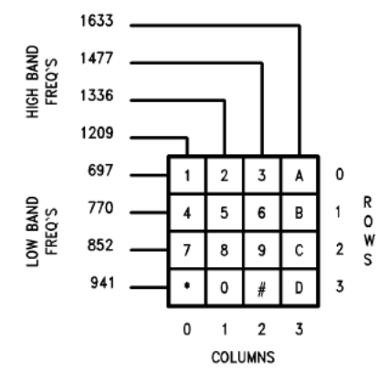Figure 8.1: DTMF keyboard
  - Indicative Solution
In this example, we will be creating the four low band signals as shown in Figure 8.1. Based on the specification, the duration of a halftone DTMF signal is Δt = 0.25 sec. To create a time-discrete signal x(n) of Δt duration, we will be using the following mathematical formula:
This formula originates from the transformation of an analogue sine signal x(t) of an analogue frequency F to a time-discrete sine signal of digital frequency , where F_{S} is the sampling frequency. The variable n corresponds to the time frame nT_{S}, where is the sampling period, i.e. the distance in time between two consecutive samples. Sampling frequency F_{S} in telecommunications is set to 8KHz, which makes us understand that in one second, we get 8000 samples. Given our need for a duration equal to Δt = 0.25 sec, we deduce that the variable n is a vector of 2000 points. The following snippet creates the clean sine signals from the low and high band:
import numpy as np
from matplotlib import pyplot as plt
import sounddevice as sd
Fs = 8000
dt = 0.25
n = np.arange(0, int(Fs * dt))
l1 = np.cos(2 * np.pi * 697 / Fs * n)
l2 = np.cos(2 * np.pi * 770 / Fs * n)
l3 = np.cos(2 * np.pi * 852 / Fs * n)
l4 = np.cos(2 * np.pi * 941 / Fs * n)
h1 = np.cos(2 * np.pi * 1209 / Fs * n)
h2 = np.cos(2 * np.pi * 1336 / Fs * n)
h3 = np.cos(2 * np.pi * 1477 / Fs * n)
h4 = np.cos(2 * np.pi * 1633 / Fs * n)
npause = int(Fs * (dt / 2))
p = np.zeros(npause)
The following code, plays the pure sine signals of both bands on the speakers. Each signal is separated from the next with the signal p which contains zeros for the representation of the pause signal.
sd.play(np.hstack((l1, p, l2, p, l3, p, l4, p, h1, p, h2, p, h3, p, h4, p)), Fs)
sd.wait() # Required so that the interpreter pauses whilst playing
Moving forward, the code below, creates the result of the summation of the corresponding low and high band signals in order to create each key on the DTMF keyboard.
dtmf1 = l1 + h1
dtmf2 = l1 + h2
dtmf3 = l1 + h3
dtmf4 = l2 + h1
dtmf5 = l2 + h2
dtmf6 = l2 + h3
dtmf7 = l3 + h1
dtmf8 = l3 + h2
dtmf9 = l3 + h3
dtmf_star = l4 + h1
dtmf0 = l4 + h2
dtmf_hashtag = l4 + h3
With which we can generate their sound equivalent using the snippet below.
dtmf = np.hstack((dtmf1, p, dtmf2, p, dtmf3, p, dtmf4, p, dtmf5, p, dtmf6, p, dtmf7, p, dtmf8, p, dtmf9, p, dtmf_star, p, dtmf0, p, dtmf_hashtag))
sd.play(dtmf, Fs)
sd.wait()
Finally, we can plot the signals versus the sample number using the following.
plt.plot(dtmf)
plt.show()
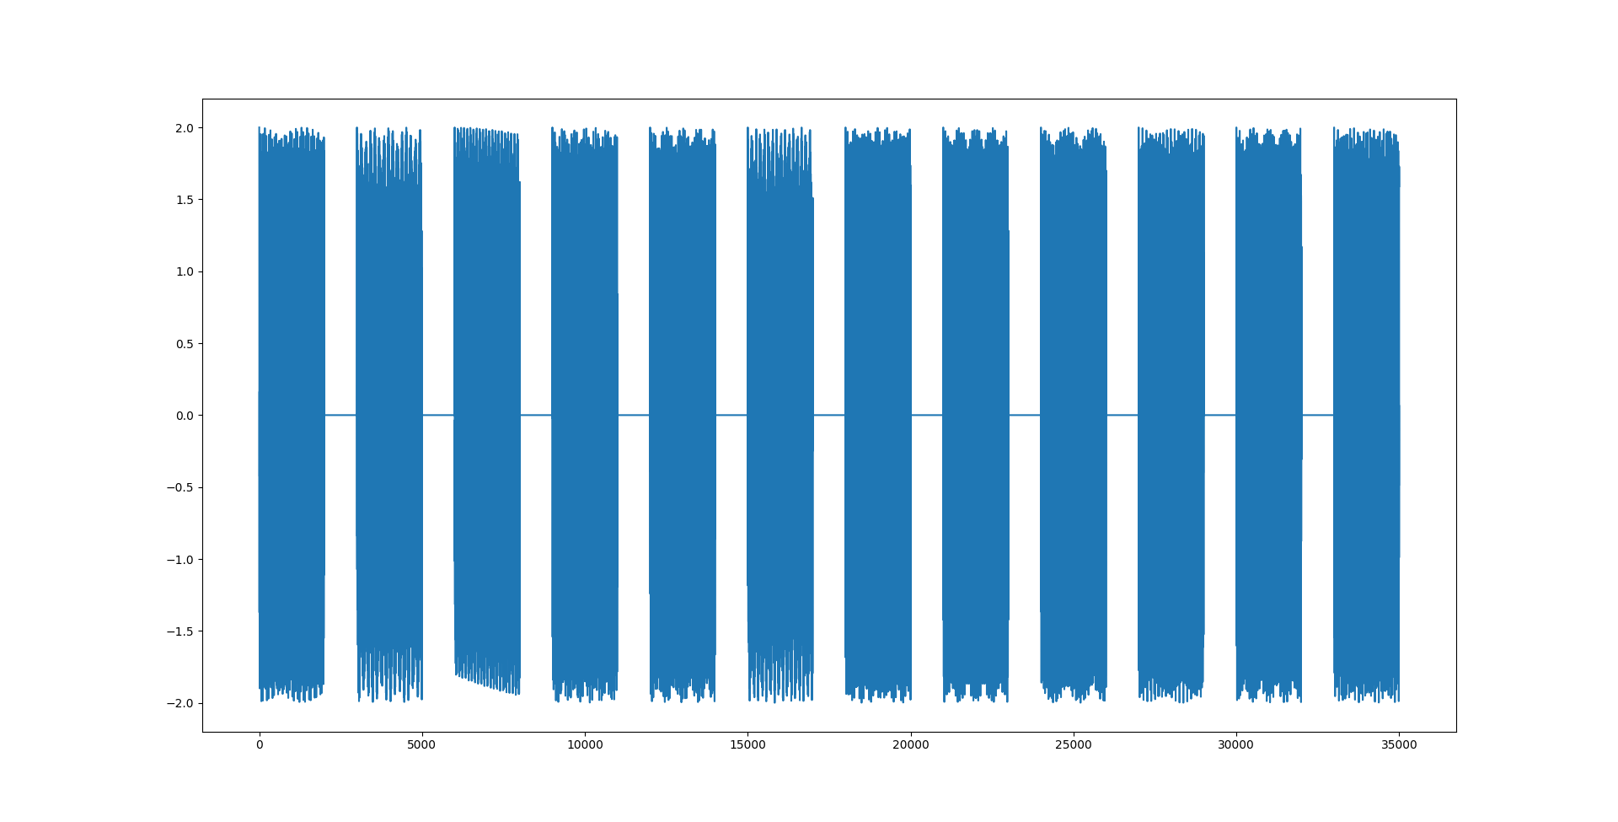Figure 8.2: DTMF signal
  - Exercises
    - Based on the above codes, create a Python script with which you will represent and listen on your speakers your 10-digit telephone number.
    - Based on the above codes, create a Python function with which you will represent and listen on your speakers any telephone number. The telephone number will be given as the parameter.
Suggestions:
      - You should check if the telephone number given is an integer.
      - You can use the following functions: len, for, if, str, isinstance
- Example: Graphical representation of magnitude and phase
  - Theoretical Background
The transfer function of a first order low-pass filter is given by the formula below:
Where V_{o}, V_{i} are the output and input signals (which correspond to a harmonic signal of frequency f) and R, C are the values of the resistance and the capacitance respectfully. The graphical representation of the response curve of the magnitude and phase is simple in Python, given that a) Python offers the ability to use complex numbers and manipulate them with a relative ease and b) the transfer function for given values of f, R, C is a complex number in fraction form. The transfer function as a complex number has a magnitude and a phase. We want the magnitude curve to have as it’s axes the frequence in a semilogaritmic scale and the gain in dB whilst the phase curve to have as axes the frequency in semilogarithmic scale and the phase in degrees.
  - Indicative Solutions
In this particular example, we will develop a function named mytrf(R, C) with parameters being the values of the resistance R and the capacitance C. The frequency range of f will be determined with the help of the product RC which defined the cut-off frequency . Given that in the frequencies close to the cut-off frequency f_{c} we want to capture many points, we divide the area in 3 sections. For example, the statement np.linspace(0, 0.8 * fc, 100) creates a vector of 100 values from the DC (with value of 0 which corresponds to 0 Hz) until of the cut-off frequency f_{c} This way, the following set of expressions create a vector containing 400 points:
import numpy as np
R = 1000
C = 1e-6
tc = R * C
fc = 1 / tc
f = np.hstack((np.linspace(0, 0.8 * fc, 100), np.linspace(0.81 * fc, 1.10 * fc, 200), np.linspace(1.11 * fc, 100 * fc, 100)))
Which then is used to create a vector of 400 complex numbers, that contains the calculated values of the transfer function formula.
tr_f = 1 / (1 + 1j * 2 * np.pi * R * C * f)
From which, the graphical representation of the magnitute can be drawn:
from matplotlib import pyplot as plt
plt.plot(np.abs(tr_f))
plt.show()
Surprisingly, we observe that the generated graph does not represent anything that connects, in some way, to our theoretical knowledge.
We expect that the graph will be improved once we understand the fact that the horizontal axis must be made of the frequency values.
plt.plot(f, np.abs(tr_f))
plt.xlabel("Frequency – Hz")
plt.show()
Even if we have not reached the desirable form of the classical response curve of a low-pass filter, we can still improve it if we transform the magnitude to a dB scale and change the horizontal axis to a semilog scale.
db = 20 * np.log10(np.abs(tr_f))
plt.semilogx(f, db)
plt.xlabel("Frequency – Hz")
plt.ylabel("dB")
plt.grid(True)
plt.grid(True, which="minor")
plt.show()
As we can see, the output is on a par with our theoretical background.
For the phase curve, we can use NumPy’s angle() function (returns an angle in radians) and the fact that π-rad (or 3.14 rad) correspond to 180^{O}. Summarizing, the following function implements all the required calculations:
import numpy as np
from matplotlib import pyplot as plt
def mytrf(R, C):
tc = R * C
fc = 1 / tc
f = np.hstack((np.linspace(0, 0.8 * fc, 100), np.linspace(0.81 * fc, 1.10 * fc, 200), np.linspace(1.11 * fc, 100 * fc, 100)))
tr_f = 1 / (1 + 1j * 2 * np.pi * R * C * f)
magn = np.abs(tr_f)
db = 20 * np.log10(magn)
phase_deg = 180 * np.angle(tr_f) / np.pi # can be substituted by np.angle(tr_f, deg=True)
plt.subplot(2, 1, 1)
plt.semilogx(f, db)
plt.xlabel("Frequency – Hz")
plt.ylabel("dB")
plt.grid(True)
plt.grid(True, which="minor")
plt.subplot(2, 1, 2)
plt.semilogx(f, phase_deg)
plt.xlabel("Frequency – Hz")
plt.ylabel("Angle – Degrees")
plt.grid(True)
plt.grid(True, which="minor")
return tr_f, db, phase_deg
Note, that we do not include the call of the show() function of pyplot in order for the user to plot multiple graphs at the same time if needed. Let us see a usage example of the function:
from matplotlib import pyplot as plt
from mytrf import mytrf
R = 1000
C = 1e-6
tr_f, db, phase_deg = mytrf(R, C)
R = 2000
C = 1e-6
tr_f1, db1, phase_deg1 = mytrf(R, C)
plt.show()

Exercises
- Develop a Python script that generates the factorial N! of an integer N. The calculation for the factorial should be done in both a non-recursive () and a recursive way ().
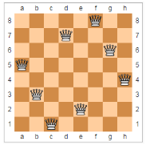
- Develop a Python script that will provide the coordinates of 8 chess queens on a chess board, which when placed on it, they won’t challenge each other like shown in the example image. The script must also save a .txt file with the coordinates saved in the following format: f 8 d 7 g 6 …
- Develop a Python script that creates a signal f(t) with the help of the following summation:
given two values of a_{k}: a) a_{k} = 1 and b) . The script must progressively plot the results. For this exercise, assume that the signal duration is 10 sec with f_{S} = 100Hz and ω = 1 (r/s).
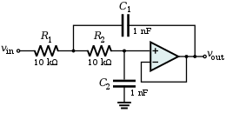
- Develop a Python script that draws the response and phase curves of the filter on the right.

Advanced Topics
As this document does not cover Python in it’s entirety, the following list contains some important aspects that anyone who wants to use Python professionally should know how to use.
- Debugging using IDLE or any other IDE
- import vs from – import for files/modules
- Pairs, Dictionaries, Sets, Tuples
- Regular Expressions
- List comprehension – Generators/Generator expressions
- Creating classes
- Lambda expressions
- Creating modules
- Standard modules (non-exhaustive list):
  - shutil – importing/exporting variables to/from Python scripts
  - collections – data containers
  - unittest – Unit testing framework
  - tkinter – GUI toolkit
  - hashlib, hmac – Hashing and message digesting
  - logging – Python logging library
  - json, xml.* – JSON/ XML processing libraries
- Type hints – Lib/typing.py
- Algorithms (not specific to Python)
- Data Structures (not specific to Python)
- Design Patterns (not specific to Python)
- Python’s code style guide / code conventions – PEP 8
- 3rd party modules (non-exhaustive list):
  - NumPy
  - matplotlib
  - pandas
  - SciPy
  - Pillow or scikit-image

Appendix A: Installation

Windows

From this page download the respective installer of the stable version of Python 3 required. Running the installer will open a window on which the choice `Add Python 3.X to PATH` at the bottom needs to be enabled. This will allow the Python Interpreter to be called from anywhere in system, making running scripts from any directory possible. Pressing `Install Now` to continue with the installation, if new to Python, else customizing what is and isn’t installed through the `Customize installation` option is available for experts. Once it is done, clicking close completes the process. Verifying the installation next is suggested, so one can be sure everything installed correctly.

Linux

Using the respective package manager (or App Store, if desktop environment that provides one is used or has been installed manually), of the distribution to install.
- For Red Hat, CentOS or Fedora, install the python3, python3-devel, python3-pip and python3-virtualenv packages.
- For Debian or Ubuntu, install the python3.x python3.x-dev, python3-pip and python3.x-venv packages, where x is the major version of Python 3.
- For other systems, or if wanted to install from source, see the general download page.

Once complete, it is suggested to verify the installation to check that everything was installed properly.

Mac

Download the installer from this page. It's recommended to download the universal installer as it will take care of figuring out your CPU model and installing the proper distribution of the version you have chosen.
Running the installer, will show a window giving basic information about Python. Clicking continue, moves to the Read Me section. Continuing on, the License section where Python's terms and conditions are shown, it's recommended to read as it states what can or can't legally be done with or to Python. Agreeing to the License in order for the installation to continue is needed. After that, the section regarding Installation Type will be shown (the Destination Select section was skipped which is normal). Clicking on customize at the bottom of the window in order to verify that the appropriate options are set. Once the required packages are ticked, pressing Install, which prompts the user to enter a password as the installer is trying to install new software to the system. Once complete, it is suggested to verify the installation to check that everything was installed properly.

Verifying the installation

In order to check if Python was installed correctly it is needed to run a couple of commands in a Command Line Interface environment. Opening up a command prompt and typing one (or multiple) of the following commands:
- python -V (Windows only)
- python --version (Windows only)
- py -V (Windows only)
- py --version (Windows only)
- python3 -V (Mac and Linux)
- python3 --version (Mac and Linux)

Should give an output similar to the following:
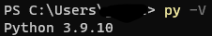

If so, the next step can be completed. If not, uninstalling and/or rerunning the installer and trying again the verification steps.

Secondly, making sure the tool pip was installed properly. It can be verified so by running one of the following commands:
- python -m pip -V (Windows only)
- python -m pip --version (Windows only)
- py -m pip -V (Windows only)
- py -m pip --version (Windows only)
- python3 -m pip -V (Mac and Linux)
- python3 -m pip –version (Mac and Linux)

Should give an output like this:
Last but not least, is verifying the installation of a tool called venv, which stands for virtual environment. Running one of the following commands based on the system:
- python -m venv (Windows)
- python -m venv (Windows)
- py -m venv (Windows)
- py -m venv (Windows)
- python3 -m venv (Mac and Linux)
- python3 -m venv (Mac and Linux)

This should produce an error similar to the following:
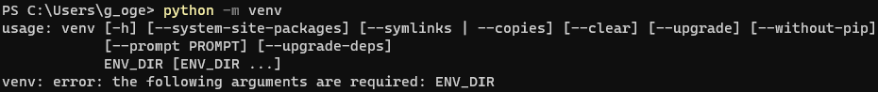
If everything showed up as it should, the installation is properly complete without any issues.

Appendix B: Python scripts, IDLE & Interactive Shell

Python offers three tools to code using the language, the primary one being writing the code in a file with the extension .py and running it by typing a command in a CLI [125] (Command Line Interface, also known as Command Prompt), by calling the Python Shell in a CLI [126] or running the Integrated Development and Learning Environment [127], which is known by its initials as IDLE. The latter two are of similar function, with the IDLE providing a graphic environment that also provides a built-in text editor in case the user wants to write code in files which will be invoked with the commands.
Executing code written in a file, is easily achieved by typing the following :

<python/python3> path-to-file

For example, if there is a python file named code.py saved in a folder inside the current folder the command prompt is running at, it can be run by typing:

<python/python3> ./<folder name>/code.py

The path can be both a relative or an absolute one, as long as it exists and is wrapped in quotation marks if it contains spaces.
The Integrated Development and Learning Environment (IDLE), is a tool created entirely out of Python code, that allows you to code in it both in an interactive way and in files. It contains a debugging tool, a file editor and a IDLE restart functionality which makes it a great place to start practicing Python and core programming skills, like debugging code. The IDLE can be opened through the programs list of the OS, which will give a window with an interactive shell. Typing code in there, will execute it instantly and show a result or information shown only when the code is run in it and not from a file. Through the `File` menu, on the upper left corner, a Python file can created or opened. Under the `Debug` menu, the Debugger can be opened, which will allow the programmer to see the call stack of each code written, so finding what’s wrong with it if it isn’t working as expected is easier. This document won’t be diving into Debugging, looking it up is suggested.
Be aware, Linux distribution don't include the IDLE in the packages instructed to download, with the reason being that some people use terminal focused environments which may not include a graphical aspect. If the IDLE is needed in a Linux distribution environment a display server protocol must be installed, like X11 or Wayland, along with the appropriate setup to use GUI applications, then running the following to install the proper package based on which distribution is used:
- For Red Hat, CentOS or Fedora, install the python3-tools package.
- For Debian or Ubuntu, install the idle3 package.
- For other systems, firstly checking up on the installed python packages in case they contain it is suggested. If it is not, then either by an app store app or directly through the package manager program of the distribution, searching for python3 packages and then piping the output to grep with the parameter “idle” should bring up some results.
A distribution may offer it under a different name, like Fedora (python3-tools). If the previous command gives no result, the best scenario would be to search the internet for the right package name.
The Python Shell is opened by typing the command python (or python3) on a command prompt, which will then start it. From there on, the usage of the Python Shell and the IDLE is similar, with the shell being a stripped out IDLE only with the most basic functionality. For the scope of this document, it's more than enough, as most operating systems have some form of a text editor included which will be utilized if needed.
Any tool or combination of them can be used to follow this document. All code snippets along with additional ones, should be included in the compressed file this document was contained in, in a folder named code examples.

Appendix C: Pip & Virtual Environments
As mentioned in Chapter 7, Python not only contains the built-in modules, but programmers can use modules other programmers created. This could be done by manually downloading each library, or using a programming language’s package/library manager. Unlike other languages, Python is shipped with a tool called pip [128], [129], that automates the download and installation of third party libraries. Using it, a programmer can install libraries on their system using simple commands in the command line interface. Once typed and the operation is completed, these libraries are available from everywhere in the system. Typing the following command in a cmd:

python/python3 -m pip

will bring up a list of what commands and flags pip contains. The most frequently used ones are:
- install package_name1[==version] package_name2[==version] ….: Downloads and installs the specified package(s). If a version number is given through the == operator, downloads and installs that specific version.
- uninstall package_name1 package_name2 ….: uninstalls and deletes the specified package(s).
- list: displays all installed packages and their version.
- freeze: prints the install packages and their version in an installation-ready format to use with the install command.
- help command_name: shows the help page for the typed command.

Besides installing each module manually, pip install contains a flag with which a programmer can pass a file as a parameter in order to install multiple modules at the same time without having to type them out. The file structure can be similar to what is shown in Image 1. Package version can be omitted if not needed. In order to install the libraries written in such a file, the pip install
command is written with the -r flag and the path to the file.
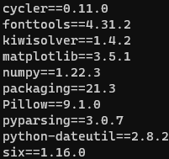Image 1: Python requirements file example.
python/python3 -m pip install -r /path/to/file
The reason for being able to have a file with the list of libraries and their versions is because different projects may have different
dependencies. But if libraries are installed system-wide, this will create conflicts if a person has different projects that require same libraries of different versions installed. That is why, along with pip, Python is shipped with another tool called venv [130], which stands for virtual environment.
This tool allows programmers to bootstrap a specific folder with it’s own, containerized Python installation that includes it’s own pip which installs packages locally, in the project directory. To use venv, the syntax is:
python/python3 -m venv [flags] /path/to/project/directory
This way, Python bootstraps that directory and the outcome is shown on Image 2. In the Scripts folder, the containerized Python and pip programs exist along with some useful scripts to enter and exit the venv container. In order to access the project’s venv, the appropriate activate script needs to be run in the cmd.
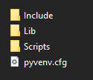Image 2: Initial venv.

./Scripts/activate (Mac and Linux)
./Scripts/activate.bat (Windows default cmd)
./Scripts/Activate.ps1 (Powershell terminal)

Running it, should bring the command line interface to a state similar to that of Image 3. Now running the python/python3 command or pip will execute the containerized applications. The latter will install packages locally, in the project folder, allowing programmers to use multiple versions of the same libraries for different projects. In order to exit the venv container, a programmer only needs to type deactivate whilst being in the command line interface and not inside a Python Interactive Shell.
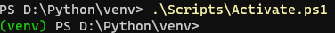Image 3: Activated venv container.

Although pip and venv are quite useful for programmers, they are not so user friendly or fully efficient. For this reason, new tools that replace them have been developed. Python programmers, at the time of writing, use either Conda, Poetry, Pipenv or Virtualenv (a superset of the built-in venv, which is actually what venv was based on). Using one of these, replaces both pip and venv and (some) being industry standard, any aspiring Python programmer would benefit from learning them. There are other alternatives that have gained some attraction and are used by programmers like Python Development Master (PDM) and Hatch, but so far they have not become industry standard or anything. For the scope of this document, pip and venv are more than enough.

References
[1] Python Software Foundation, "The Python Tutorial", Python 3.9.13, Available: https://docs.python.org/3.9/tutorial/#the-python-tutorial (accessed: July 19, 2022)
[2] Python Software Foundation, "2.3. Identifiers and keywords", Python 3.9.13 Documentation, Available: https://docs.python.org/3.9/reference/lexical_analysis.html#identifiers (accessed: July 19, 2022)
[3] Python Foundation Software, "7.2. Assignment statements", Python 3.9.13 Documentation, Available: https://docs.python.org/3.9/reference/simple_stmts.html#assignment-statements (accessed: July 19, 2022)
[4] Wikipedia, "Literal (computer programming)", Wikipedia, Available: https://en.wikipedia.org/wiki/Literal_(computer_programming) (accessed: July 19, 2022)
[5] Python Software Foundation, "3. An Informal Introduction to Python", Python 3.9.13 Documentation, Available: https://docs.python.org/3.9/tutorial/introduction.html#an-informal-introduction-to-python (accessed: July 19, 2022)
[6] Python Software Foundation, "3.1.1. Numbers", Python 3.9.13 Documentation, Available: https://docs.python.org/3.9/tutorial/introduction.html#numbers (accessed: July 19, 2022)
[7] Python Software Foundation, "3.1.2. Strings", Python 3.9.13 Documentation, Available: https://docs.python.org/3.9/tutorial/introduction.html#strings (accessed: July 19, 2022)
[8] Baeldung, "Expression vs. Statement", Computer Science, Available: https://www.baeldung.com/cs/expression-vs-statement (accessed: July 19, 2022)
[9] Python Software Foundation, "Built-in Types", Python 3.9.13 Documentation, Available: https://docs.python.org/3.9/library/stdtypes.html#built-in-types (accessed: July 19, 2022)
[10] Python Software Foundation, "Numeric Types -- int, float, complex", Python 3.9.13, Available: https://docs.python.org/3.9/library/stdtypes.html#numeric-types-int-float-complex (accessed: July 19, 2022)
[11] Python Software Foundation, "Bitwise Operations on Integer Types", Python 3.9.13, Available: https://docs.python.org/3.9/library/stdtypes.html#bitwise-operations-on-integer-types (accessed: July 19. 2022)
[12] Python Software Foundation, "7.2.1. Augmented assignment statements", Python 3.9.13 Documentation, Available: https://docs.python.org/3.9/reference/simple_stmts.html#augmented-assignment-statements (accessed: July 19, 2022)
[13] MathWorks, "Data Types", MATLAB & Simulink, Available: https://www.mathworks.com/help/MATLAB/data-types.html (accessed: July 26, 2022)
[14] MathWorks, "Numeric Types", MATLAB & Simulink, Available: https://www.mathworks.com/help/MATLAB/numeric-types.html (accessed: July 26, 2022)
[15] MathWorks, "Characters and Strings", MATLAB & Simulink, Available: https://www.mathworks.com/help/MATLAB/characters-and-strings.html (accessed: July 26, 2022)
[16] MathWorks, "MATLAB Operators and Special Characters", MATLAB & Simulink, Available: https://www.mathworks.com/help/MATLAB/MATLAB_prog/MATLAB-operators-and-special-characters.html (accessed: July 26, 2022)
[17] MathWorks, "Solve systems of linear equations xA = B for x", MATLAB & Simulink, Available: https://www.mathworks.com/help/MATLAB/ref/mrdivide.html (accessed: July 26, 2022)
[18] MathWorks, "Solve systems of linear equations Ax = B for x", MATLAB & Simulink, Available: https://www.mathworks.com/help/MATLAB/ref/mldivide.html (accessed: July 26, 2022)
[19] MathWorks, "Remainder after division (modulo operation)", MATLAB & Simulink, Available: https://www.mathworks.com/help/MATLAB/ref/mod.html (accessed: July 26, 2022)
[20] MathWorks, "Bit-Wise Operations", MATLAB & Simulink, Available: https://www.mathworks.com/help/MATLAB/bit-wise-operations.html (accessed: )
[21] MathWorks, "Bit-wise AND", MATLAB & Simulink, Available: https://www.mathworks.com/help/MATLAB/ref/bitand.html (accessed: July 26, 2022)
[22] MathWorks, "Bit-wise OR", MATLAB & Simulink, Available: https://www.mathworks.com/help/MATLAB/ref/bitor.html (accessed: July 26, 2022)
[23] MathWorks, "Bit-wise XOR", MATLAB & Simulink, Available: https://www.mathworks.com/help/MATLAB/ref/bitxor.html (accessed: July 26, 2022)
[24] MathWorks, "Bit-wise complement", MATLAB & Simulink, Available: https://www.mathworks.com/help/MATLAB/ref/bitcmp.html (accessed: July 26, 2022)
[25] MathWorks, "Shift bits specified number of places", MATLAB & Simulink, Available: https://www.mathworks.com/help/MATLAB/ref/bitshift.html (accessed: July 26, 2022)
[26] Python Software Foundation, "Built-in functions - print", Python 3.9.13, Available: https://docs.python.org/3.9/library/functions.html#print (accessed: July 19, 2022)
[27] Python Software Foundation, "Built-in functions - input", Python 3.9.13, Available: https://docs.python.org/3.9/library/functions.html#input (accessed: July 19, 2022)
[28] Python Software Foundation, "Built-in Functions - int", Python 3.9.13, Available: https://docs.python.org/3.9/library/functions.html#int (accessed: July 19, 2022)
[29] Python Software Foundation, "Built-in Functions - float", Python 3.9.13, Available: https://docs.python.org/3.9/library/functions.html#float (accessed: July 19, 2022)
[30] Python Software Foundation, "Built-in Functions - str", Python 3.9.13, Available: https://docs.python.org/3.9/library/functions.html#func-str (accessed: July 19, 2022)
[31] Python Software Foundation, "Built-in Functions - hex", Python 3.9.13, Available: https://docs.python.org/3.9/library/functions.html#hex (accessed: July 19, 2022)
[32] Python Software Foundation, "Built-in Functions - oct", Python 3.9.13, Available: https://docs.python.org/3.9/library/functions.html#oct (accessed: July 19, 2022)
[33] Python Software Foundation, "Built-in Functions - bin", Python 3.9.13, Available: https://docs.python.org/3.9/library/functions.html#bin (accessed: July 19, 2022)
[34] MathWorks, "Display value on variable", MATLAB & Simulink, Available: https://www.mathworks.com/help/MATLAB/ref/disp.html (accessed: July 26, 2022)
[35] MathWorks, "Request user input", MATLAB & Simulink, Available: https://www.mathworks.com/help/MATLAB/ref/input.html (accessed: July 26, 2022)
[36] MathWorks, "Conver character array or string to numeric array", MATLAB & Simulink, Available: https://www.mathworks.com/help/MATLAB/ref/str2num.html (accessed: July 26, 2022)
[37] MathWorks, "Convert numbers to character array", MATLAB & Simulink, Available: https://www.mathworks.com/help/MATLAB/ref/num2str.html (accessed: July 26, 2022)
[38] MathWorks, "Convert decimal integer to its hexadecimal representation", MATLAB & Simulink, Available: https://www.mathworks.com/help/MATLAB/ref/dec2hex.html (accessed: July 26, 2022)
[39] MathWorks, "Convert decimal integer to its binary representation", MATLAB & Simulink, Available: https://www.mathworks.com/help/MATLAB/ref/dec2bin.html (accessed: July 26, 2022)
[40] MathWorks, "Convert text representation of hexadecimal integer to double value", MATLAB & Simulink, Available: https://www.mathworks.com/help/MATLAB/ref/hex2dec.html (accessed: July 26, 2022)
[41] MathWorks, "Convert text representation of binary integer to double value", MATLAB & Simulink, Available: https://www.mathworks.com/help/MATLAB/ref/bin2dec.html (accessed: July 26, 2022)
[42] MathWorks, "Convert decimal integer to its base-n representation", MATLAB & Simulink, Available: https://www.mathworks.com/help/MATLAB/ref/dec2base.html (accessed: July 26, 2022)
[43] MathWorks, "Convert octal to decimal numbers", MATLAB & Simulink, Available: https://www.mathworks.com/help/comm/ref/oct2dec.html (accessed: July 26, 2022)
[44] Python Software Foundation, "Boolean Values", Python 3.9.13, Available: https://docs.python.org/3.9/library/stdtypes.html#boolean-values (accessed: July 19, 2022)
[45] Python Software Foundation, "Boolean Operations -- and, or, not", Python 3.9.13, Available: https://docs.python.org/3.9/library/stdtypes.html#boolean-operations-and-or-not (accessed: July 19, 2022)
[46] Python Software Foundation, "Comparisons", Python 3.9.13, Available: https://docs.python.org/3.9/library/stdtypes.html#comparisons (accessed: July 19, 2022)
[47] Python Software Foundation, "6.10.1. Value comparisons", Python 3.9.13, Available: https://docs.python.org/3/reference/expressions.html#value-comparisons (accessed: July 19, 2022)
[48] Python Software Foundation, "4.1. if Statements", Python 3.9.13, Available: https://docs.python.org/3.9/tutorial/controlflow.html#if-statements (accessed: July 19, 2022)
[49] Python Software Foundation, "8.1. The if statement", Python 3.9.13, Available: https://docs.python.org/3.9/reference/compound_stmts.html#if (accessed: )
[50] Python Software Foundation, "6.13. Conditional expressions", Python 3.9.13, Available: https://docs.python.org/3/reference/expressions.html#conditional-expressions (accessed: July 19, 2022)
[51] Python Software Foundation, "3.2. First Steps Towards Programming", Python 3.9.13, Available: https://docs.python.org/3.9/tutorial/introduction.html#first-steps-towards-programming (accessed: July 19, 2022)
[52] Python Software Foundation, "4.2. for Statements", Python 3.9.13, Available: https://docs.python.org/3.9/tutorial/controlflow.html#for-statements (accessed: July 19, 2022)
[53] Python Software Foundation, "8.3. The for statement", Python 3.9.13, Available: https://docs.python.org/3.9/reference/compound_stmts.html#for (accessed: July 19, 2022)
[54] Python Software Foundation, "Built-in Types - range", Python 3.9.13, Available: https://docs.python.org/3.9/library/stdtypes.html#range (accessed: July 19, 2022)
[55] Python Software Foundation, "Sequence Types -- list, tuple, range", Python 3.9.13, Available: https://docs.python.org/3.9/library/stdtypes.html#sequence-types-list-tuple-range (accessed: July 19, 2022)
[56] MathWorks, "Convert numeric values to logicals", MATLAB & Simulink, Available: https://www.mathworks.com/help/MATLAB/ref/logical.html (accessed: July 26, 2022)
[57] MathWorks, "Logical (Boolean) Operations", MATLAB & Simulink, Available: https://www.mathworks.com/help/MATLAB/logical-operations.html (accessed: July 26, 2022)
[58] MathWorks, "Execute statements if condition is true", MATLAB & Simulink, Available: https://www.mathworks.com/help/MATLAB/ref/if.html (accessed: July 26, 2022)
[59] MathWorks, "while loop to repeat when condition is true", MATLAB & Simulink, Available: https://www.mathworks.com/help/MATLAB/ref/while.html (accessed: July 26, 2022)
[60] MathWorks, "for loop to repeat specified number of times", MATLAB & Simulink, Available: https://www.mathworks.com/help/MATLAB/ref/for.html (accessed: July 26, 2022)
[61] Python Software Foundation, "3.1.3. Lists", Python 3.9.13, Available: https://docs.python.org/3.9/tutorial/introduction.html#lists (accessed: July 19, 2022)
[62] Python Software Foundation, "Built-in Types - list", Python 3.9.13, Available: https://docs.python.org/3.9/library/stdtypes.html#list (accessed: July 19, 2022)
[63] Python Software Foundation, "6.2.5. List displays", Python 3.9.13, Available: https://docs.python.org/3.9/reference/expressions.html#list-displays (accessed: July 19, 2022)
[64] Python Software Foundation, "6.15. Expression lists", Python 3.9.13, Available: https://docs.python.org/3.9/reference/expressions.html#expression-lists (accessed: July 19, 2022)
[65] Python Software Foundation, "Common Sequence Operations", Python 3.9.13, Available: https://docs.python.org/3.9/library/stdtypes.html#common-sequence-operations (accessed: July 19, 2022)
[66] Python Software Foundation, "Mutable Sequence Types", Python 3.9.13, Available: https://docs.python.org/3.9/library/stdtypes.html#mutable-sequence-types (accessed: July 19, 2022)
[67] Python Software Foundation, "Built-in Types - list.sort", Python 3.9.13, Available: https://docs.python.org/3.9/library/stdtypes.html#list.sort (accessed: July 19, 2022)
[68] MathWorks, "Creating, Concatenating, and Expanding Matrices", MATLAB & Simulink, Available: https://www.mathworks.com/help/MATLAB/math/creating-and-concatenating-matrices.html (accessed: July 28, 2022)
[69] MathWorks, "String array", MATLAB & Simulink, Available: https://www.mathworks.com/help/MATLAB/ref/string.html (accessed: July 28, 2022)
[70] Python Software Foundation, "Built-in Functions - help", Python 3.9.13, Available: https://docs.python.org/3.9/library/functions.html#help (accessed: July 19, 2022)
[71] Python Software Foundation, "Built-in Functions", Python 3.9.13, Available: https://docs.python.org/3.9/library/functions.html (accessed: July 19, 2022)
[72] Python Software Foundation, "4.6. Defining Functions", Python 3.9.13, Available: https://docs.python.org/3.9/tutorial/controlflow.html#defining-functions (accessed: July 20, 2022)
[73] Python Software Foundation, "8.6. Function definitions", Python 3.9.13, Available: https://docs.python.org/3.9/reference/compound_stmts.html#function-definitions (accessed: July 20, 2022)
[74] Python Software Foundation, "4.7.1. Default Argument Values", Python 3.9.13, Available: https://docs.python.org/3.9/tutorial/controlflow.html#default-argument-values (accessed: July 20, 2022)
[75] Python Software Foundation, "6. Modules", Python 3.9.13, Available: https://docs.python.org/3.9/tutorial/modules.html (accessed: July 20, 2022)
[76] Python Software Foundation, "6.1. More on Modules", Python 3.9.13, Available: https://docs.python.org/3.9/tutorial/modules.html#more-on-modules (accessed: July 20, 2022)
[77] MathWorks, "Help for functions in Command Window", MATLAB & Simulink, Available: https://www.mathworks.com/help/MATLAB/ref/help.html (accessed: Aug. 2, 2022)
[78] MathWorks, "Reference page in Help browser", MATLAB & Simulink, Available: https://www.mathworks.com/help/MATLAB/ref/doc.html (accessed: Aug. 2, 2022)
[79] MathWorks, "Create Functions in Files", MATLAB & Simulink, Available: https://www.mathworks.com/help/MATLAB/MATLAB_prog/create-functions-in-files.html (accessed: Aug. 2, 2022)
[80] Python Software Foundation, "7.2. Reading and Writing Files", Python 3.9.13, Available: https://docs.python.org/3.9/tutorial/inputoutput.html#reading-and-writing-files (accessed: July 20, 2022)
[81] Python Software Foundation, "Built-in Functions - open", Python 3.9.13, Available: https://docs.python.org/3.9/library/functions.html#open (accessed: July 20, 2022)
[82] Python Software Foundation, "7.2.1. Methods of File Objects", Python 3.9.13, Available: https://docs.python.org/3.9/tutorial/inputoutput.html#methods-of-file-objects (accessed: July 20, 2022)
[83] MathWorks, "Read lines of a file as string array", MATLAB & Simulink, Available: https://www.mathworks.com/help/MATLAB/ref/readlines.html (accessed: Aug. 2, 2022)
[84] Python Software Foundation, "math -- Mathematical functions", Python 3.9.13, Available: https://docs.python.org/3.9/library/math.html (accessed: )
[85] Python Software Foundation, "cmath -- Mathematical functions for complex numbers", Python 3.9.13, Available: https://docs.python.org/3.9/library/cmath.html (accessed: July 20, 2022)
[86] Python Software Foundation, "array -- Efficient arrays of numeric values", Python 3.9.13, Available: https://docs.python.org/3.9/library/array.html (accessed: July 20, 2022)
[87] Python Software Foundation, "csv -- CSV File Reading and Writing", Python 3.9.13, Available: https://docs.python.org/3.9/library/csv.html (accessed: July 20, 2022)
[88] Python Software Foundation, "Dialects and Formatting Parameters", Python 3.9.13, Available: https://docs.python.org/3.9/library/csv.html#dialects-and-formatting-parameters (accessed: July 20, 2022)
[89] Python Software Foundation, "datetime -- Basic date and time types", Python 3.9.13, Available: https://docs.python.org/3.9/library/datetime.html (accessed: July 20, 2022)
[90] NumPy documentation team, "numpy.array", NumPy v1.23 Manual, Available: https://numpy.org/doc/stable/reference/generated/numpy.array.html#numpy.array (accessed: July 20, 2022)
[91] NumPy documentation team, "numpy.ndarray", NumPy v1.23 Manual, Available: https://numpy.org/doc/stable/reference/generated/numpy.ndarray.html#numpy.ndarray (accessed: July 20, 2022)
[92] NumPy documentation team, "numpy.arange", NumPy v1.23 Manual, Available: https://numpy.org/doc/stable/reference/generated/numpy.arange.html#numpy.arange (accessed: July 20, 2022)
[93] NumPy documentation team, "numpy.ndarray.reshape", NumPy v1.23 Manual, Available: https://numpy.org/doc/stable/reference/generated/numpy.ndarray.reshape.html#numpy.ndarray.reshape (accessed: July 20, 2022)
[94] NumPy documentation team, "numpy.reshape", NumPy v1.23 Manual, Available: https://numpy.org/doc/stable/reference/generated/numpy.reshape.html#numpy.reshape (accessed: July 20, 2022)
[95] NumPy documentation team, "numpy.linspace", NumPy v1.23 Manual, Available: https://numpy.org/doc/stable/reference/generated/numpy.linspace.html#numpy.linspace (accessed: July 20, 2022)
[96] NumPy documentation team, "numpy.ndarray.dot", NumPy v1.23 Manual, Available: https://numpy.org/doc/stable/reference/generated/numpy.ndarray.dot.html#numpy.ndarray.dot (accessed: July 20, 2022)
[97] NumPy documentation team, "numpy.dot", NumPy v1.23 Manual, Available: https://numpy.org/doc/stable/reference/generated/numpy.dot.html#numpy.dot (accessed: July 20, 2022)
[98] NumPy documentation team, "numpy.eye", NumPy v1.23 Manual, Available: https://numpy.org/doc/stable/reference/generated/numpy.eye.html#numpy.eye (accessed: July 20, 2022)
[99] NumPy documentation team, "numpy.ones", NumPy v1.23 Manual, Available: https://numpy.org/doc/stable/reference/generated/numpy.ones.html#numpy.ones (accessed: July 20, 2022)
[100] NumPy documentation team, "numpy.zeros", NumPy v1.23 Manual, Available: https://numpy.org/doc/stable/reference/generated/numpy.zeros.html#numpy.zeros (accessed: July 20, 2022)
[101] NumPy documentation team, "numpy.full", NumPy v1.23 Manual, Available: https://numpy.org/doc/stable/reference/generated/numpy.full.html#numpy.full (accessed: July 20, 2022)
[102] NumPy documentation team, "numpy.sqrt", NumPy v1.23 Manual, Available: https://numpy.org/doc/stable/reference/generated/numpy.sqrt.html#numpy.sqrt (accessed: July 20, 2022)
[103] NumPy documentation team, "numpy.log", NumPy v1.23 Manual, Available: https://numpy.org/doc/stable/reference/generated/numpy.log.html#numpy.log (accessed: July 20, 2022)
[104] NumPy documentation team, "numpy.log2", NumPy v1.23 Manual, Available: https://numpy.org/doc/stable/reference/generated/numpy.log2.html#numpy.log2 (accessed: July 20, 2022)
[105] NumPy documentation team, "numpy.log10", NumPy v1.23 Manual, Available: https://numpy.org/doc/stable/reference/generated/numpy.log10.html#numpy.log10 (accessed: July 20, 2022)
[106] NumPy documentation team, "numpy.cos", NumPy v1.23 Manual, Available: https://numpy.org/doc/stable/reference/generated/numpy.cos.html#numpy.cos (accessed: July 20, 2022)
[107] NumPy documentation team, "numpy.exp", NumPy v1.23 Manual, Available: https://numpy.org/doc/stable/reference/generated/numpy.exp.html#numpy.exp (accessed: July 20, 2022)
[108] NumPy documentation team, "numpy.sum", NumPy v1.23 Manual, Available: https://numpy.org/doc/stable/reference/generated/numpy.sum.html#numpy.sum (accessed: July 20, 2022)
[109] NumPy documentation team, "numpy.prod", NumPy v1.23 Manual, Available: https://numpy.org/doc/stable/reference/generated/numpy.prod.html#numpy.prod (accessed: July 20, 2022)
[110] NumPy documentation team, "numpy.linalg.det", NumPy v1.23 Manual, Available: https://numpy.org/doc/stable/reference/generated/numpy.linalg.det.html#numpy-linalg-det (accessed: July 20, 2022)
[111] NumPy documentation team, "numpy.linalg.inv", NumPy v1.23 Manual, Available: https://numpy.org/doc/stable/reference/generated/numpy.linalg.inv.html#numpy-linalg-inv (accessed: July 20, 2022)
[112] NumPy documentation team, "The N-dimensional array (ndarray)", NumPy v1.23 Manual, Available: https://numpy.org/doc/stable/reference/arrays.ndarray.html#the-n-dimensional-array-ndarray (accessed: July 20, 2022)
[113] Matplotlib programmers, "matplotlib.pyplot.plot", Matplotlib 3.5.2 documentation, Available: https://matplotlib.org/stable/api/_as_gen/matplotlib.pyplot.plot.html#matplotlib-pyplot-plot (accessed: July 20, 2022)
[114] Matplotlib programmers, "matplotlib.pyplot.stem", Matplotlib 3.5.2 documentation, Available: https://matplotlib.org/stable/api/_as_gen/matplotlib.pyplot.stem.html#matplotlib-pyplot-stem (accessed: July 20, 2022)
[115] Matplotlib programmers, "matplotlib.pyplot.scatter", Matplotlib 3.5.2 documentation, Available: https://matplotlib.org/stable/api/_as_gen/matplotlib.pyplot.scatter.html#matplotlib-pyplot-scatter (accessed: July 20, 2022)
[116] Matplotlib programmers, "matplotlib.pyplot.hist", Matplotlib 3.5.2 documentation, Available: https://matplotlib.org/stable/api/_as_gen/matplotlib.pyplot.hist.html#matplotlib-pyplot-hist (accessed: July 20, 2022)
[117] Matplotlib programmers, "matplotlib.pyplot.semilogx", Matplotlib 3.5.2 documentation, Available: https://matplotlib.org/stable/api/_as_gen/matplotlib.pyplot.semilogx.html#matplotlib-pyplot-semilogx (accessed: July 20, 2022)
[118] Matplotlib programmers, "matplotlib.pyplot.semilogy", Matplotlib 3.5.2 documentation, Available: https://matplotlib.org/stable/api/_as_gen/matplotlib.pyplot.semilogy.html#matplotlib-pyplot-semilogy (accessed: July 20, 2022)
[119] Matplotlib programmers, "matplotlib.pyplot.loglog", Matplotlib 3.5.2 documentation, Available: https://matplotlib.org/stable/api/_as_gen/matplotlib.pyplot.loglog.html#matplotlib-pyplot-loglog (accessed: July 20, 2022)
[120] Matplotlib programmers, "matplotlib.pyplot.figure", Matplotlib 3.5.2 documentation, Available: https://matplotlib.org/stable/api/_as_gen/matplotlib.pyplot.figure.html#matplotlib-pyplot-figure (accessed: July 20, 2022)
[121] Matplotlib programmers, "matplotlib.pyplot.subplot", Matplotlib 3.5.2 documentation, Available: https://matplotlib.org/stable/api/_as_gen/matplotlib.pyplot.subplot.html#matplotlib-pyplot-subplot (accessed: July 20, 2022)
[122] Matplotlib programmers, "matplotlib.pyplot.subplot", Matplotlib 3.5.2 documentation, Available: https://matplotlib.org/stable/api/_as_gen/matplotlib.pyplot.show.html#matplotlib-pyplot-show (accessed: July 20, 2022)
[123] Matplotlib programmers, "Examples - 3D plotting", Matplotlib 3.5.2 documentation, Available: https://matplotlib.org/stable/gallery/index.html#d-plotting (accessed: July 20, 2022)
[124] Pillow community, "Image Module", Pillow (PIL Fork) 9.2.0 documentation, Available: https://pillow.readthedocs.io/en/stable/reference/Image.html#image-module (accessed: July 20, 2022)
[125] Python Software Foundation, "1.1. Command line", Python 3.9.13, Available: https://docs.python.org/3.9/using/cmdline.html#command-line (accessed: July 20, 2022)
[126] Python Software Foundation, "2.1.2. Interactive Mode", Python 3.9.13, Available: https://docs.python.org/3.9/tutorial/interpreter.html#interactive-mode (accessed: July 20, 2022)
[127] Python Software Foundation, "IDLE", Python 3.9.13, Available: https://docs.python.org/3.9/library/idle.html?highlight=idle (accessed: July 20, 2022)
[128] Python Software Foundation, "Installing Python Modules", Python 3.9.13, Available: https://docs.python.org/3.9/installing/index.html#installing-python-modules (accessed: July 20, 2022)
[129] Python Software Foundation, "12.3. Managing Packages with pip", Python 3.9.13, Available: https://docs.python.org/3.9/tutorial/venv.html#managing-packages-with-pip (accessed: July 20, 2022)
[130] Python Software Foundation, "12.2 Creating Virtual Environments", Python 3.9.13, Available: https://docs.python.org/3.9/tutorial/venv.html#creating-virtual-environments (accessed: July 20, 2022)

Not to be confused with the assignment operator which is one `=` symbol, the Equality operator is written with two `=` symbols.
Flow charts created using draw.io, a free and open source software.
The try statement – https://docs.python.org/3.9/reference/compound_stmts.html#the-try-statement
A pair can be thought of as a list with only two items. It’s elements can be accessed similarly to a list, e.g. pair[0] and pair[1].
This example uses the 3rd party module called sounddevice, a free and open source library for playing audio through Python. For any issues with it, navigate through it’s documentation for possible solutions.
SciPy can also be used, specifically the freqs() function from it’s signal module. It also allows passing a callable object to automatically handle the plotting. SciPy offers many more utilities on a variety of fields, such as optimization, DSP, differential equations and more.

